**Human Body Avatar Data Analysis Project User’s Manual**

**Introduction**:

The Avatar Data Analysis GUI was created to assist the user in analyzing the error in the equations used to calculate body measurements form digital scans of the subject when compared to the conventional methods of finding body measurements. It would allow the user to input the data gathered by conventional methods and load the data gathered from the digital scanners. Then, the interface would allow the user to find the error within individual subjects and within groups of subjects.

This project was done by Dr. Wolenski and his Fall 2017 class for the capstone course at Louisiana State University to assist researchers at Pennington Biomedical Research Center performer measurements that may be used in future human health projects.

The Interface consists of 4 tabs:

Tab 1 – Conventional Measurements Data Entry

Tab 2 – Digital Measurements Data Loading

Tab 3 – Individual Subject Error

Tab 4 – Group Error and Correlations

**General Buttons:**

The  Button in the upper left-hand corner is a global save button that will store the data as a separate file on the local computer.

The  Button in the upper left-hand corner is a global open button that would load a file from the local computer.

**Tab 1**:

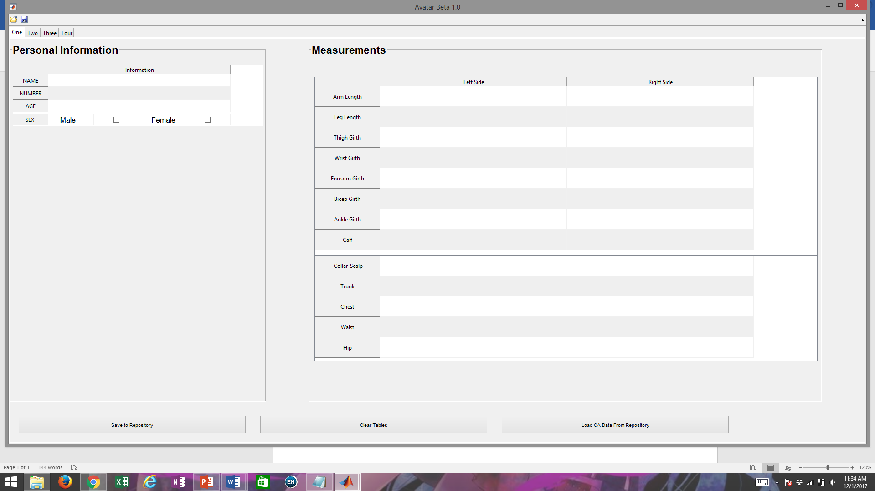

This tab contains the input tables that would allow the user to input data directly into the tables and save the data to the repository. The table on the left are for subject identification data, and the table on the right are for the conventional measurement input.

The “Save to Repository” Button will save the input data into the repository that is automatically loaded when the interface is loaded. It will continuously add cells as the user adds subjects.

The “Clear Tables’ Button will clear all data from the tables.

The “Load CA Data from Repository” Button will load a previously saved file in the repository to be viewed again.

**Tab 2**:

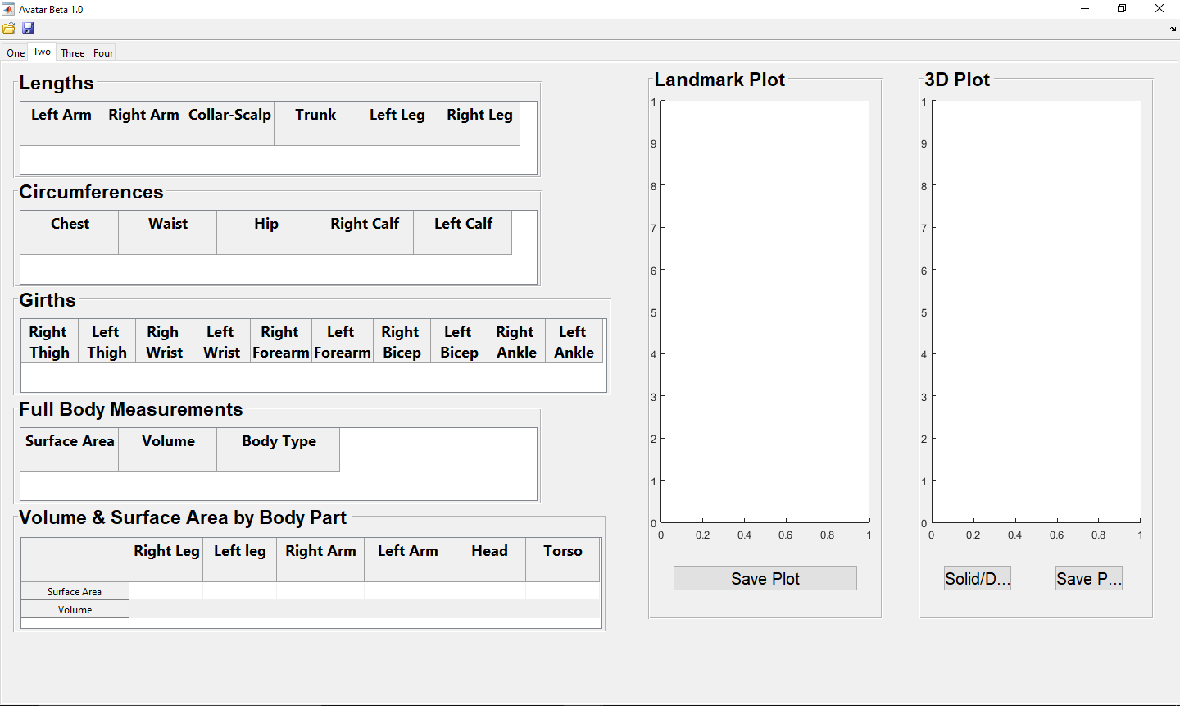

Click the Open Button to open the file server and upload the subject “.obj” file.

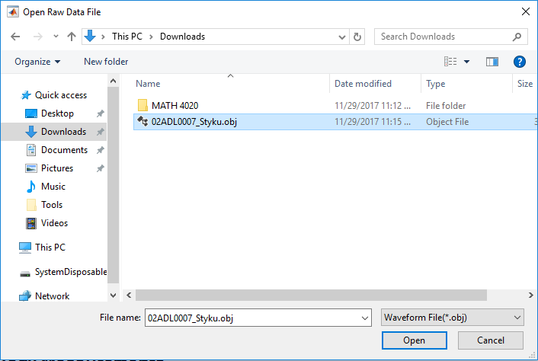

Select the subject “.obj” file that is to be loaded and click open.

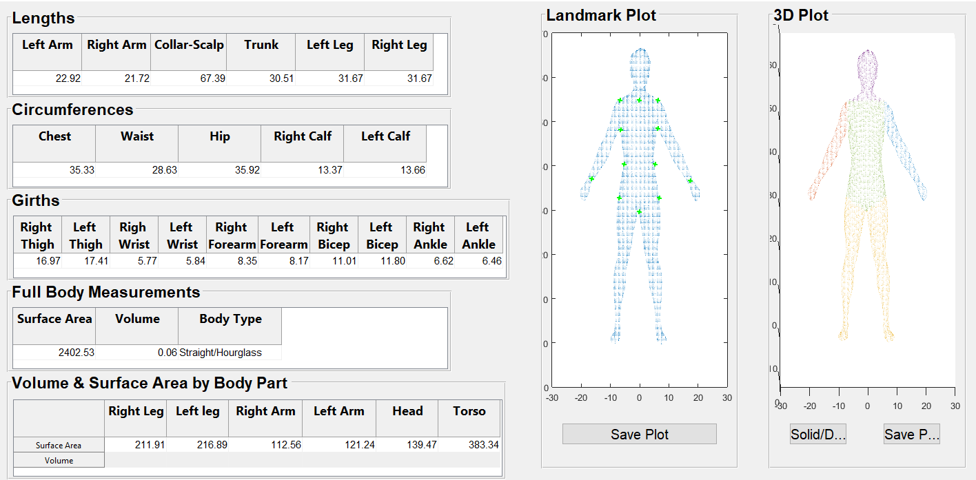

The data will load after a short wait. Data are automatically saved into the repository in the row corresponding to the subject’s number.

**Tab 3**:

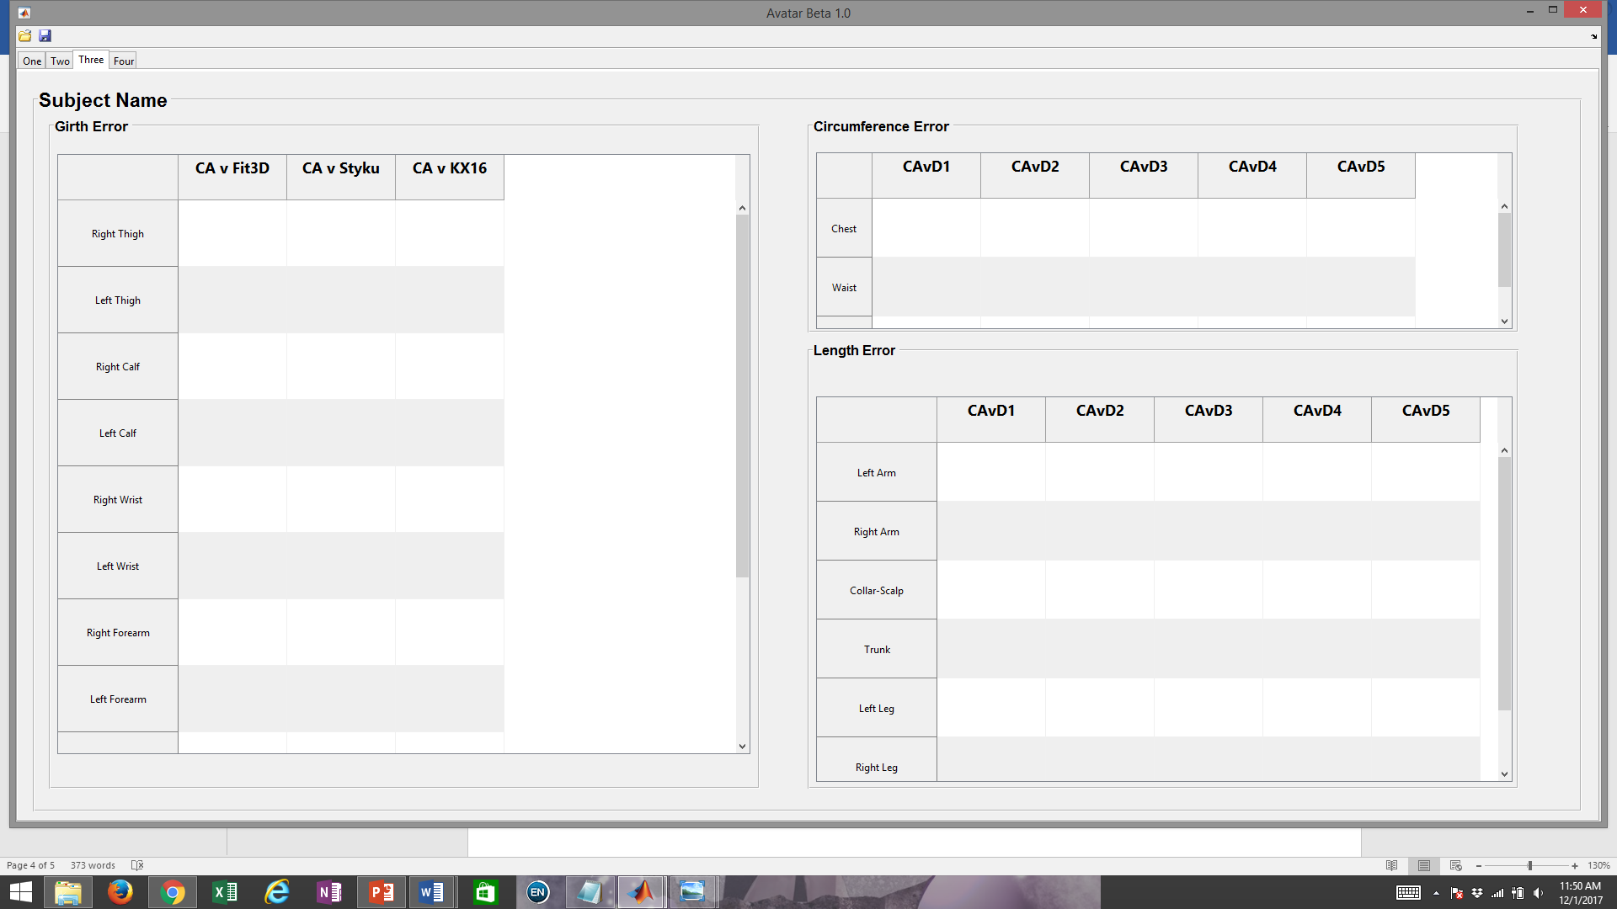

Table 3 should just display the error data between Tab 1 and Tab 2. The error data for the subject should appear as the DA measurements are loaded into Tab 2.

**Tab 4**:

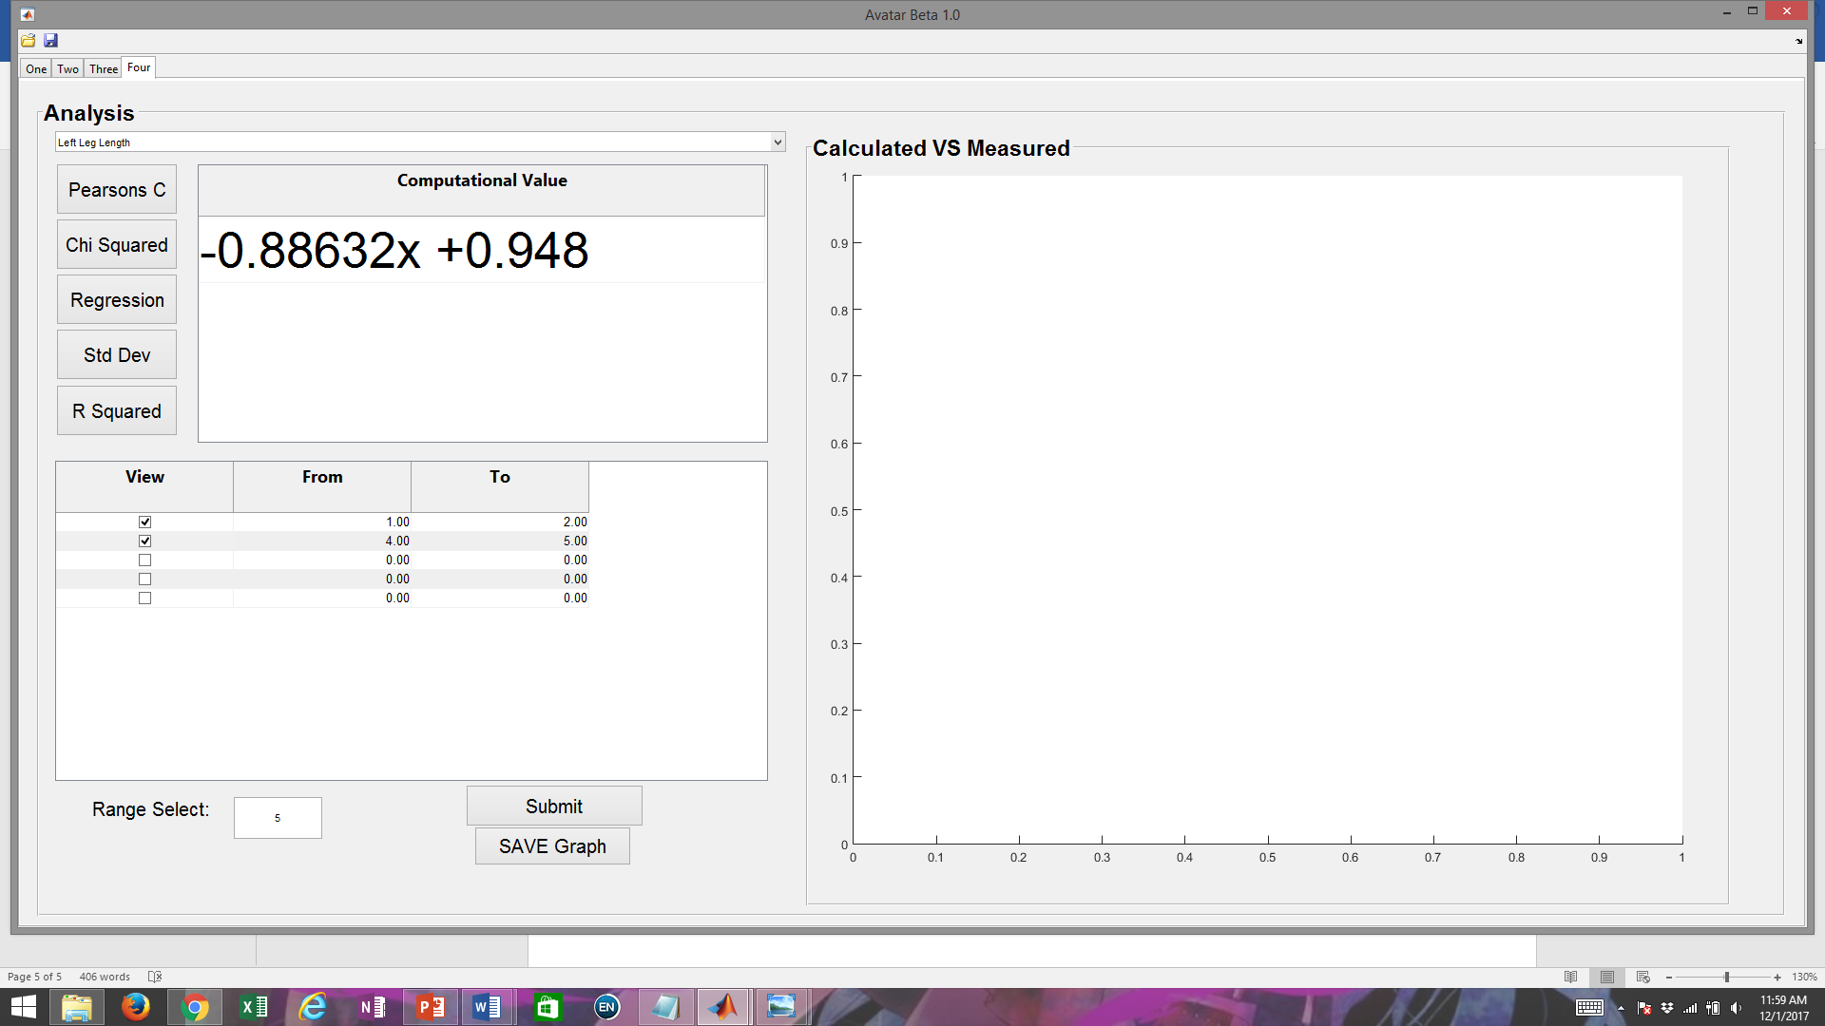

Tab 4 would be the group analysis tab.



The user must select a number of ranges that he or she wishes to compare together. The number of ranges to be observed would then be inserted into the box next to “Range Select.” Then, the user hits the “Submit” button to load that number of entry boxes into the Table above. In each row, the user is able to type in the ranges in the repository that he or she wants to observe and analyze together.



Once the ranges are selected, the user may select the specific measurements to within the repository to observe and compare. Then, the user may decide to observe the correlation between the CA measurements and DA Measurements with the “Pearson’s Correlation Coefficient”, “R squared”, and “Chi Square” Buttons.

Pearson’s Correlation Coefficient and R square values that are closer to 1 have a stronger correlation than values that are close to 0.

Chi Square requires observation compared to the table provided.

The “Regression” button will provide the formula of a linear regression line that shows the correlation between the CA measurements and the DA measurements. The graph would only show this relationship.

The “Standard Deviation” button would should the general grouping of the data in general.

*Chi Square Table:*

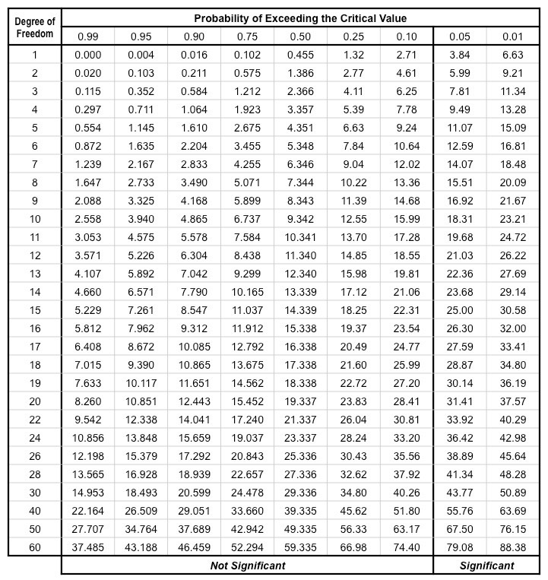

**Conclusion**:

The Avatar Data Analysis GUI provides an interface for the user to analyze to see the amount of error within the equations used to create the measurements from the digital scanners. The results would help refine the equations and reduce the error to make the digital measurements as close to the conventional measurements as much as possible. Once a highly precise and accurate equation is obtain, the equation may be used in future biomedical research to future human health research.