Coreq Support for Section 4.2

# Topic 1: Determining if the Graph of a Quadratic Function Opens Up or Down

Whether a quadratic function is written in the form  or in the form , the value of $a$ determines the direction that the parabola opens:

If  the parabola opens up and has a minimum value at the vertex.

If , the parabola opens down and has a maximum value at the vertex.

# Topic 2: Determining Relative Maximum and Relative Minimum Values of a Function

In section 3.2, we learned how to identify relative maximum and minimum values of a function when given its graph.

When a function  changes from increasing to decreasing at a point , then *f*  is said to have a relative maximum at . The relative maximum value is .

When a function  changes from decreasing to increasing at a point , then *f* is said to have a relative minimum at . The relative minimum value is .

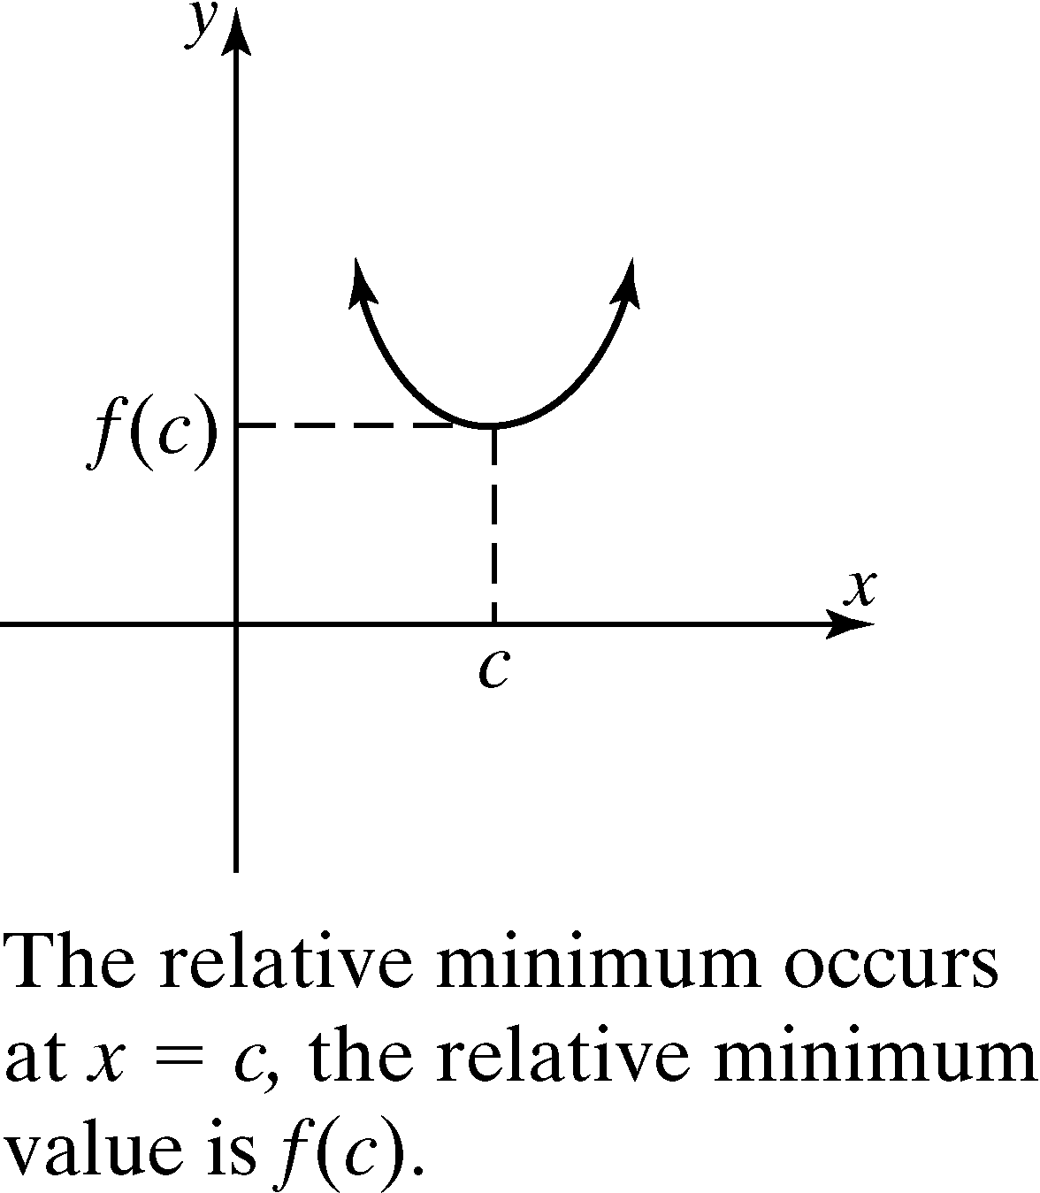 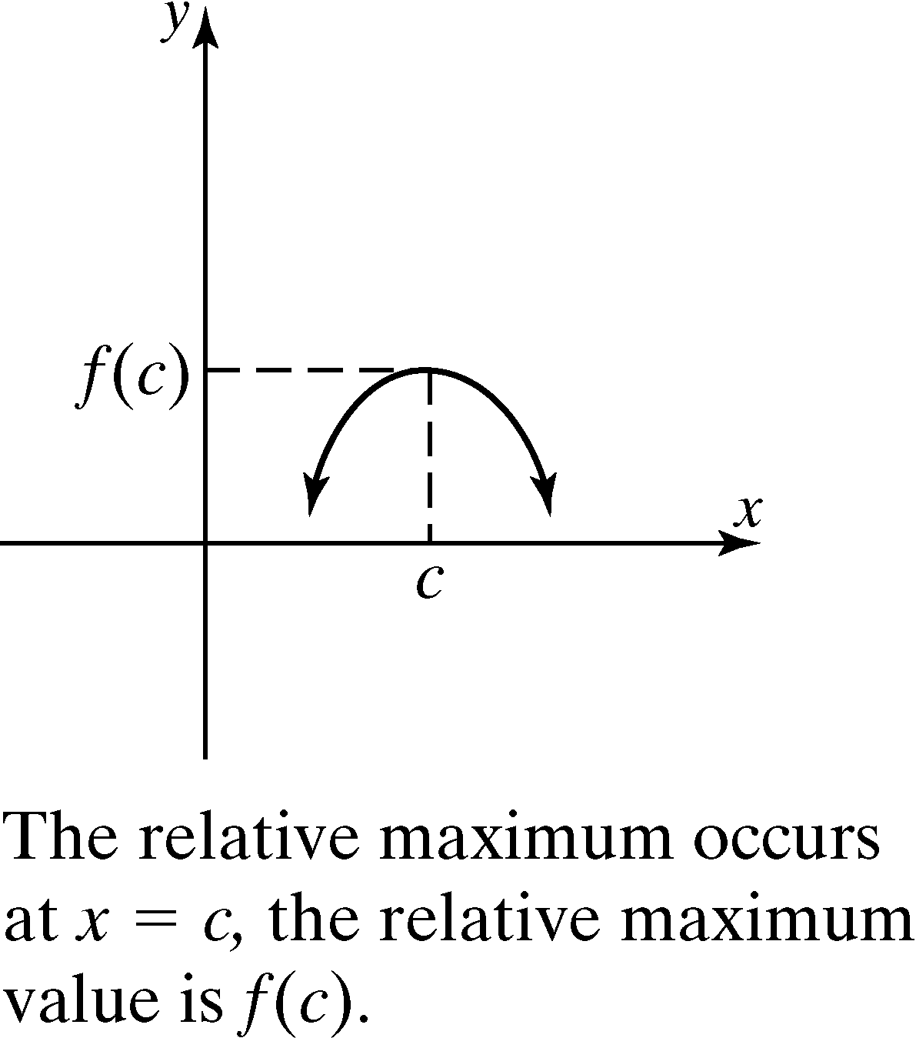

# Topic 3: Adding and Subtracting Polynomials; Multiplying a Polynomial by a Monomial