Coreq Support for Section 3.3

# Topic 1: Using the Vertical Line Test

# (Video: Functions 6:43 – 11:35)

When an $x$-coordinate is paired with more than one $y$-coordinate, a vertical line can be drawn that will intersect the graph at more than one point. We can use this fact to determine whether a relation is also a function. We call this the **vertical line test**.

**The Vertical Line Test**

A graph in the Cartesian plane is the graph of a function if and only if no vertical line intersects the graph more than once.

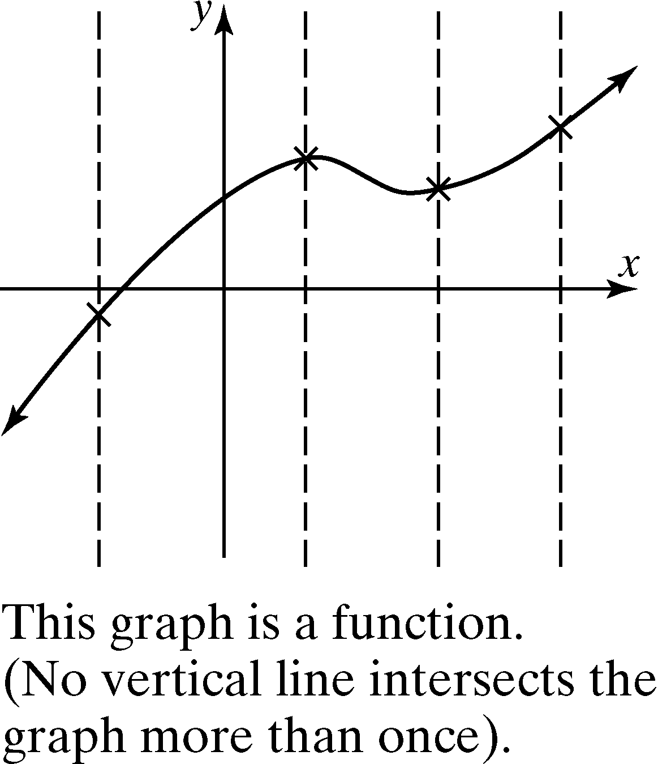 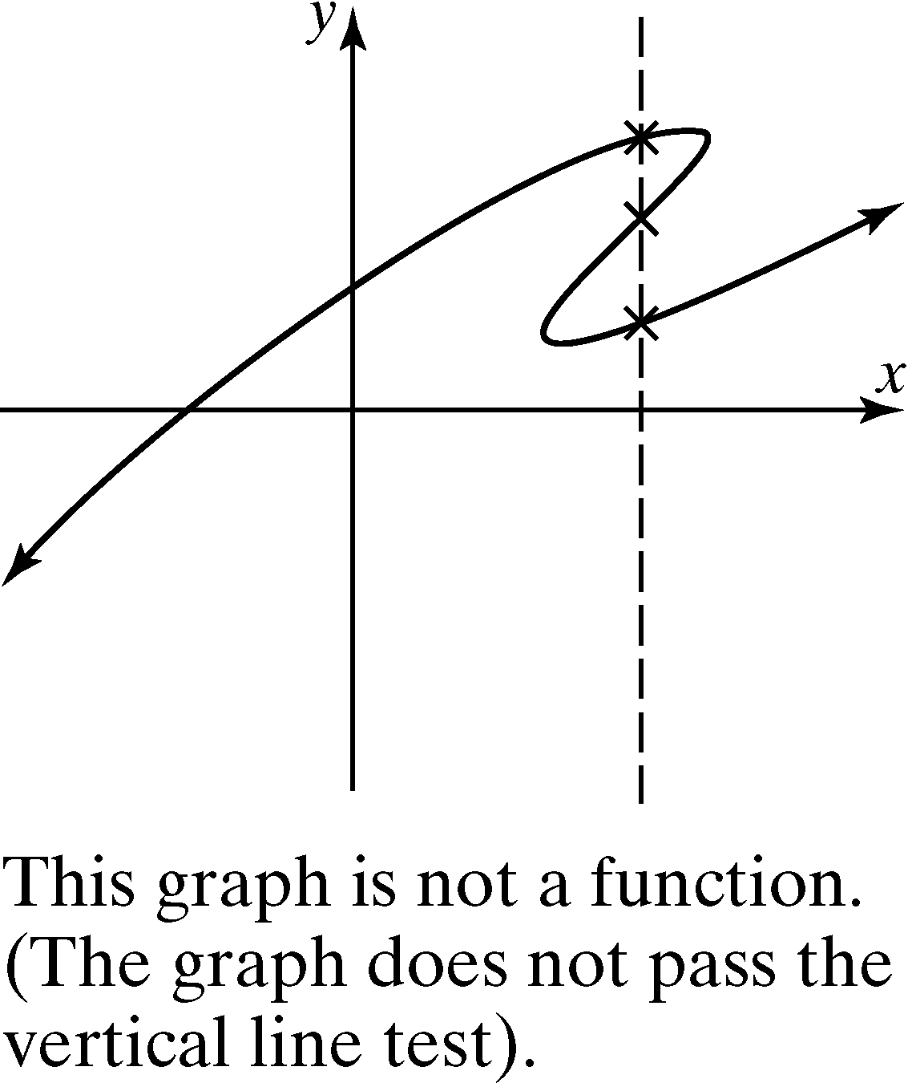

# Topic 2: Using Function Notation

# (Video: Functions 13:45 – 20:38)

Consider the linear equation . This linear equation describes a function because every *x*-coordinate is paired with exactly one *y*-coordinate. The variable *y* is a function of the variable *x*. We say the variable *x* is the **independent variable** because any value in the domain can be assigned to *x*. The variable *y* is the **dependent variable** because its value depends on *x*.

The symbol means function of *x* and is read “ $f$ of *x*.” This notation is called **function notation**. The equation  can be written as  using function notation. These equations have the same meaning. In other words, $.$

The notation  means replace *x* with $1$ and find the resulting *y* or function value.





Since , we know the ordered pair  is a point on the graph of the linear function .

# Topic 3: Determining the Domain and Range of a Function from its Graph

**Topic 4: Sketching the Graphs of Linear Functions**

A **linear function** has the form  where $m$ is the slope of the line and $b$ is the *y*-intercept.

The **constant function** is defined by the equation , the graph of which is a horizontal line.

The **identity function** defined by  is another linear function with  and .