7.4 Inverse Trigonometric Functions I

# OBJECTIVE 1: Understanding and Finding the Exact and Approximate Values of the Inverse Sine Function

The graph of the sine function, , is shown below. Think of the independent variable, x, as an angle given in radians. It will be helpful throughout this section to visualize the quadrant or axis where the terminal side of each angle you encounter lies. In the graph below, each subinterval of length , such as , is labeled with I, II, III, or IV to show that an angle in that subinterval lies in the listed quadrant.

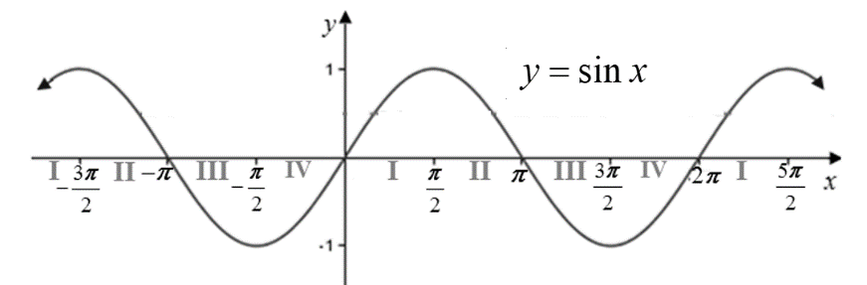

The domain of  is , and the sine function is clearly not one-to-one on its entire domain since it does not pass the horizontal line test. Therefore, in order to find an inverse function for the sine function, we must restrict the domain to a closed interval to produce a graph that is one-to-one. There are many possible choices. We will use the traditional choice of the interval . Notice that this interval shows the entire range of  for .

To establish the graph of the inverse sine function, , start with the graph of the restricted sine function which contains the points , , and . Reverse the coordinates of each ordered pair, and connect these new points with a smooth curve, remembering that the graphs of a function and its inverse function are symmetric about the line . The graph of will contain the points , , and , and will have domain  and range . Notice that if , then the value of  is an angle whose terminal side lies in Quadrant IV, and if , then the value of is an angle whose terminal side lies in Quadrant I.

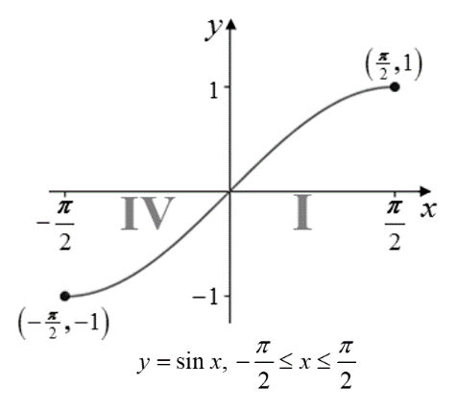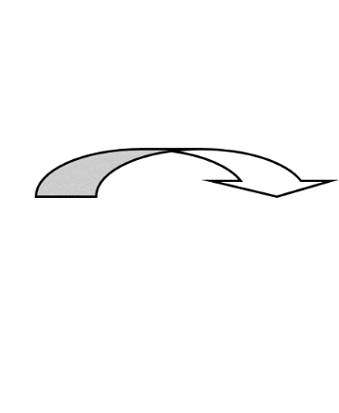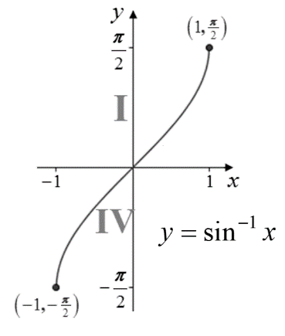

The **inverse sine function**, denoted as  (or sometimes ), is the inverse of , . The **domain** of  is and the **range** is .

To determine the exact value of , think of the expression as the angle on the interval whose sine is equal to *x*. Use conventional angle notation, , to represent the value of . If , then . Therefore, **the terminal side of angle  must lie in Quadrant I, in Quadrant IV, on the positive *x-*axis, on the positive *y-*axis , or on the negative *y-*axis.**

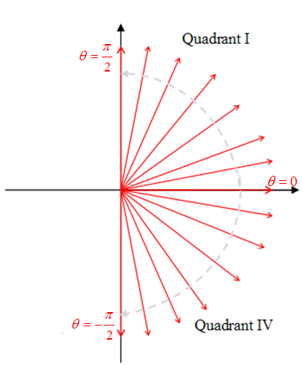

**Steps for Determining the Exact Value of **

1. If *x* is in the interval , then the value of must be an angle in the interval .  
   Let  such that .
2. If , then  and the terminal side of angle  lies on the positive *x-*axis. See Figure 1 below.

If , then  and the terminal side of angle  lies in Quadrant I or on the positive *y-*axis. See Figure 2 below.

If , then and the terminal side of angle  lies in Quadrant IV or on the negative *y-*axis. See Figure 3 below.

1. Use your knowledge of the two special right triangles, the graphs of the trigonometric functions, and the exact values of the trigonometric functions of angles in the special families to determine the angle in the correct quadrant whose sine is *x*.

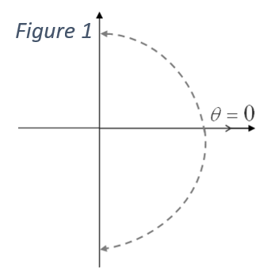 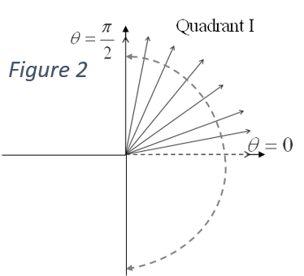 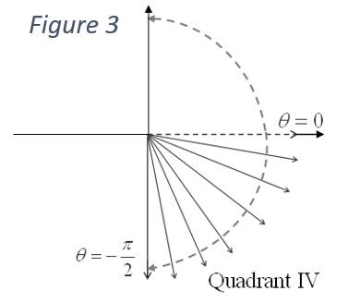

# OBJECTIVE 2: Understanding and Finding the Exact and Approximate Values of the Inverse Cosine Function

The graph of the cosine function, , is shown below with each subinterval of length , such as , labeled with I, II, III, or IV to show that an angle in that subinterval lies in the listed quadrant.

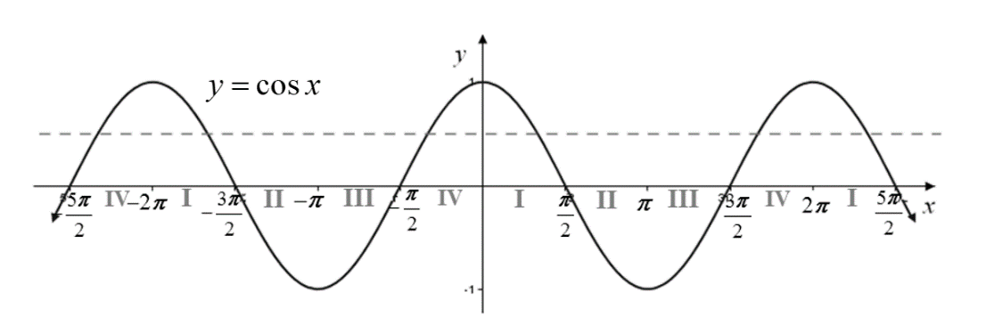

The domain of  is , and the cosine function is clearly not one-to-one on its entire domain since it does not pass the horizontal line test. Therefore, in order to find an inverse function for the cosine function, we must restrict the domain to a closed interval to produce a graph that is one-to-one. There are many possible choices. We will use the traditional choice of the interval

. Notice that this interval shows the entire range of  for .

To establish the graph of the inverse cosine function, , start with the graph of the restricted cosine function which contains the points , , and . Reverse the coordinates of each ordered pair, and connect these new points with a smooth curve, remembering that the graphs of a function and its inverse function are symmetric about the line . The graph of will contain the points , , and  and will have domain  and range . Notice that if  , then the value of  is an angle whose terminal side lies in Quadrant II, and if , then the value of is an angle whose terminal side lies in Quadrant I.

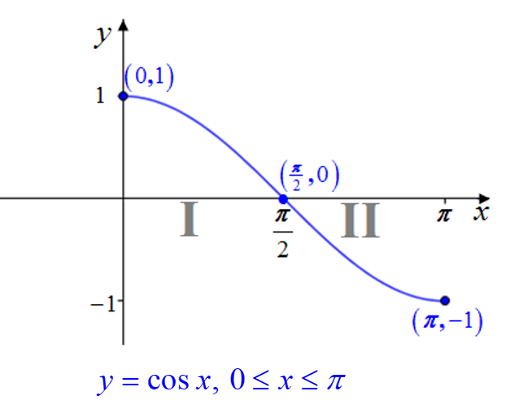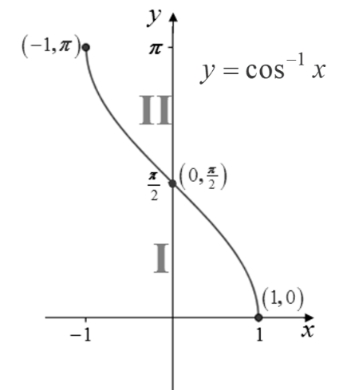

The **inverse cosine function**, denoted as  (or sometimes ), is the inverse of , . The **domain** of  is and the **range** is .

Think of the expression  as the angle on the interval  whose cosine is equal to *x*. It is important to notice that the interval  is quite different from the interval used to describe the range of the inverse sine function. It is customary to use the notation, , to represent the value of . Therefore, if , then . Thus, **the terminal side of angle**  **must lie in Quadrant I, in Quadrant II, on the positive *y-*axis, on the positive *x-*axis, or on the negative *x-*axis.**

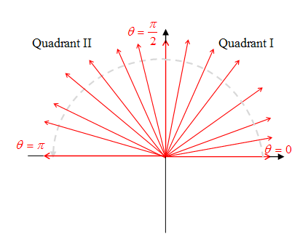

**Steps for Determining the Exact Value of **

1. If *x* is in the interval , then the value of must be an angle in the interval .
2. Let  such that .  
   If , then  and the terminal side of angle  lies on the positive *y-*axis. See Figure 4 below.

If , then  and the terminal side of angle  lies in Quadrant I or on the positive *x-*axis. See Figure 5 below.

If , then and the terminal side of angle  lies in Quadrant II or on the negative *x-*axis. See Figure 6 below.

1. Use your knowledge of the two special right triangles, the graphs of the trigonometric functions, and the exact values of the trigonometric functions of angles in the special families to determine the angle in the correct quadrant whose cosine is *x*.

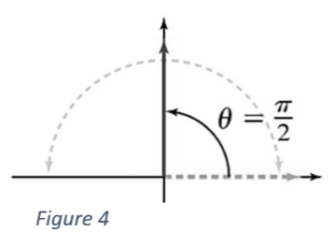 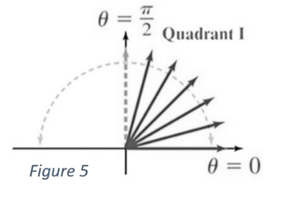 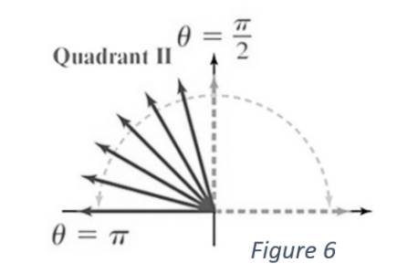

# OBJECTIVE 3: Understanding and Finding the Exact and Approximate Values of the Inverse Tangent Function

The graph of the tangent function, , is shown below with each subinterval of length  labeled with I, II, III, or IV to show that an angle in that subinterval lies in the listed quadrant.

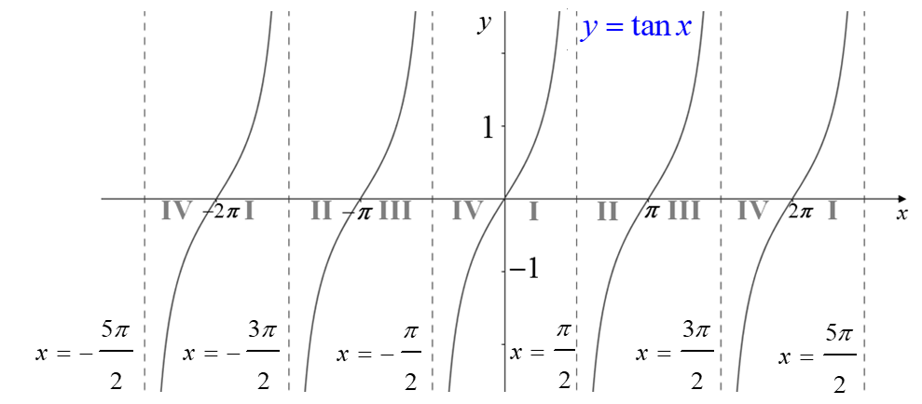

In order to find an inverse function for the tangent function, we must restrict the domain to produce a graph that is one-to-one. There are many possible choices. We will use the traditional choice of the interval of the principal cycle  showing the entire range .

To establish the graph of the inverse tangent function, , start with the graph of the restricted tangent function which contains the points , , and  and has vertical asymptotes at  . Reverse the coordinates of each ordered pair, and connect these new points with a smooth curve, remembering that the graphs of a function and its inverse function are symmetric about the line . The graph of  will contain the points , , and , will have horizontal asymptotes at , and will have domain  and range . Notice that if , then the value of  is an angle whose terminal side lies in Quadrant IV, and if , then the value of is an angle whose terminal side lies in Quadrant I.

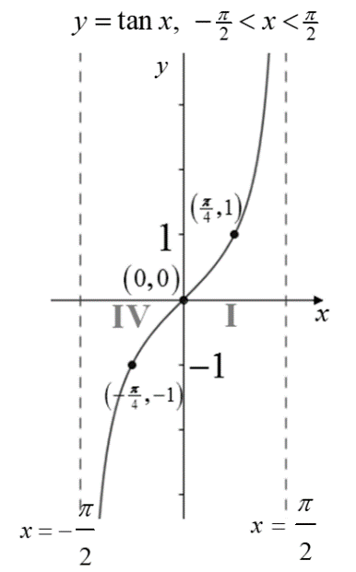 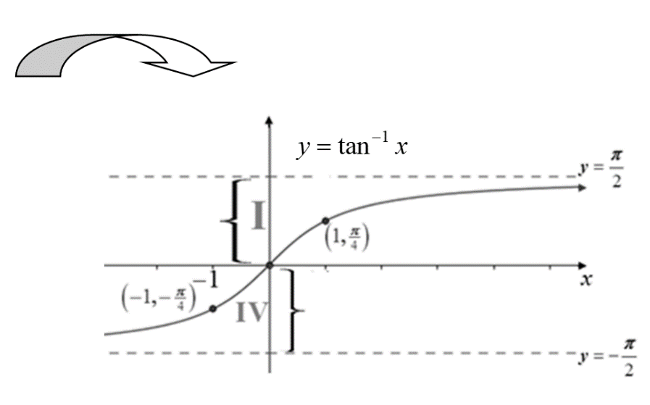

The **inverse tangent function**, denoted as  (or sometimes ), is the inverse of , . The **domain** of  is all real numbers and the **range** is .

Think of the expression  as the angle on the interval  whose tangent is equal to *x*. Use conventional angle notation, , to represent the value of . If , then . Therefore, **the terminal side of angle  must lie in Quadrant I, in Quadrant IV, or on the positive *x-*axis.**

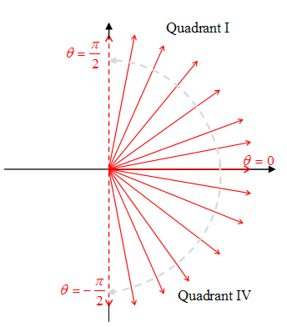

**Steps for Determining the Exact Value of** 

1. The value of  must be an angle in the interval .
2. Let  such that .
3. If , then  and the terminal side of angle  lies on the positive *x-*axis. See Figure 7 below.

If , then and the terminal side of angle  lies in Quadrant I. See Figure 8 below.

If , then and the terminal side of angle  lies in Quadrant IV. See Figure 9 below.

1. Use your knowledge of the two special right triangles, the graphs of the trigonometric functions, and the exact values of the trigonometric functions of angles in the special families to determine the angle in the correct quadrant whose tangent is *x*.

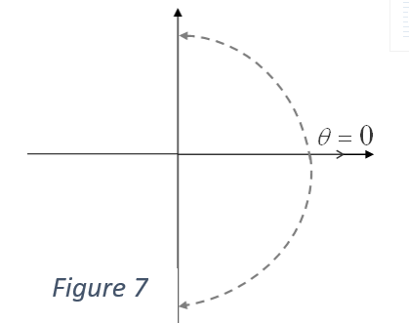 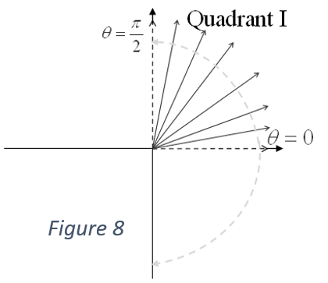 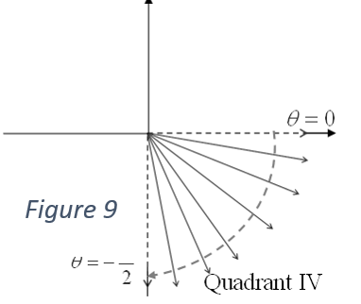

Do not confuse the notation  with . The negative 1 is not an exponent! Thus, .