6.2 Applications of Radian Measure

# OBJECTIVE 1: Determining the Area of a Sector of a Circle

For a circle of radius *r*, and central angle of  radians, the **area**, *A*, **of a sector** of a circle is given by.

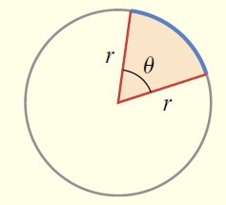

warning**The formula for the area of a sector of a circle,**  **is only valid if the angle  is in radians. An angle given in degrees must first be converted to radians.**

**OBJECTIVE 2: Computing the Arc Length of a Sector of a Circle**

The arc length of a sector of a circle depends on the corresponding central angle that intercepts the arc and the length of the radius of the circle.

For a circle of radius *r*, the **length**, *s*, **of the arc** intercepted by a central angle of  radians is given by.

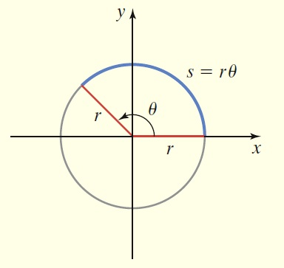

warning**The arc length formula**  **is only valid if the angle**  **is in radians. An angle given in degrees must first be converted to radians.**