Section 5.5 Applications of Exponential and Logarithmic Functions

# Objective 1: Solving Compound Interest Applications

The **Periodic Compound Interest Formula** is, where *A* is the total amount in the account after *t* years, *P* is the principal (original investment amount), *r* is the annual interest rate as a decimal, and *n* is the number of times interest is compounded per year.

The **Continuous Compound Interest Formula** is, where *A* is the total amount in the account after *t* years, *P* is the principal (original investment amount), and *r* is the annual interest rate as a decimal.

# Objective 2: Exponential Growth and Decay Applications

**Uninhibited Exponential Growth**

The **uninhibited exponential growth model** is used when a population grows at a rate proportional to the size of its population and continues to grow without any limiting factors.

This model that describes the population, *P*, after a certain time, *t,* iswhere is the initial population and is a constant called the **relative growth rate**. (Note: *k* may be given as a percent.)

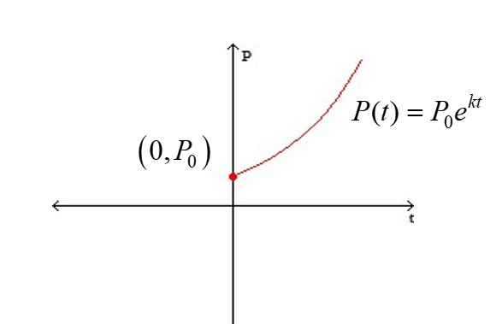

**Uninhibited Exponential Decay**

The **uninhibited exponential decay model** is used when a population decays (or declines) at a rate proportional to the size of its population and continues to decay without any limiting factors. The unhibited exponential growth and decay models are the same except for the sign of the constant, *k*.

This model that describes the exponential decay of a population, quantity, or amount *A*, after a certain time, *t,* iswhere is the initial quantity and is a constant called the **relative decay constant**. (Note: *k* is sometimes given as a percent.)

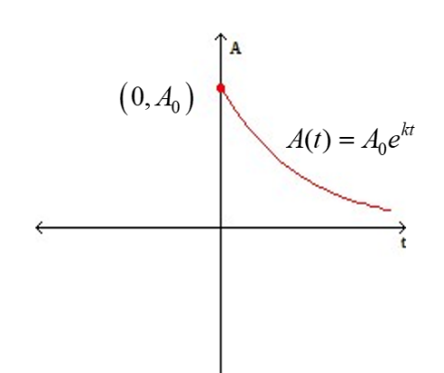

**Half-Life:** Every radioactive substance has a half-life, which is the required time for a given quantity of that element to decay to half of its original mass.

In other words,

half-life is the time, *t*, it takes for the amount present, *A*, to equal half the initial amount,   
and in symbols,

half-life is *t* when .