Section 2.2 Circles

A **circle** is the set of all points in the Cartesian plane that are a fixed distance *r* from a fixed point . The fixed distance *r* is called the **radius** of the circle and the fixed point  is called the **center** of the circle. To derive the equation of a circle, we use the distance formula that was discussed in the previous section.

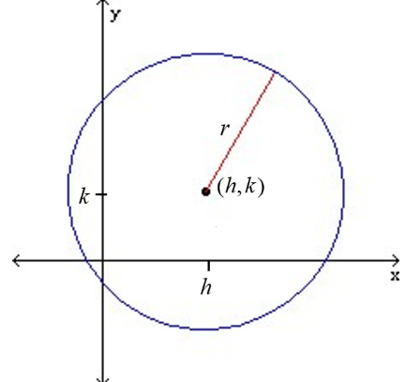

The **standard form of an equation of a circle** with center and radius *r* is .

The standard form of an equation of a circle centered at the origin with radius *r* is .

# Objective 1: Writing the Standard Form of an Equation of a Circle

Note that when given the diameter of a circle, we can use the midpoint formula to determine the center and the distance formula to find the radius.

# Objective 2: Sketching the Graph of a Circle

Once we know the center and radius of a circle, we can easily graph the circle. For additional points, find any intercepts and plot the points.

Note that the *y-*coordinate of the center of the circle  is  because .

# Objective 3: Converting the General Form of a Circle into Standard Form

The **general form of the equation of a circle** is where

are real numbers, , , and .

By completing the square, the equation of a circle can be rewritten from general form to standard form.