Section 1.8 Absolute Value Equations

When solving an absolute value equation or inequality, it is necessary to first isolate the absolute value expression.

# Objective 1: Solving an Absolute Value Equation

The absolute value of a number *x*, written as , represents the **distance** from a number *x* to 0 on the number line. Consider the equation . To solve for *x*, we must find all values of *x* that are 5 units away from 0 on the number line. The two numbers that are 5 units away from 0 on the number line are  as shown in the figure below. Therefore, the solution set for  is .

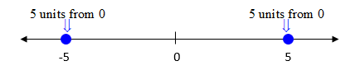

In general, if *u* is an algebraic expression and *c* is a positive real number, then is equivalent to .