Section 6.7 Exponential Growth and Decay Functions

# A quantity that grows or decays by the same percent at regular time periods is said to have exponential growth or exponential decay.

# Objective 1: Modeling Exponential Growth

We being with exponential growth which we can model using the formula shown below.

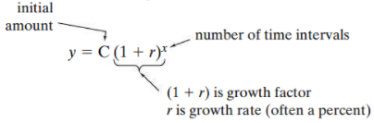

Suppose a city has a population of $150,000$ and has been growing at a rate of $2.3\%$ per year. If this trend continues, what will the population of the city be in $15$ years?

# Objective 2: Modeling Exponential Decay

We can model exponential decay using the formula shown below.

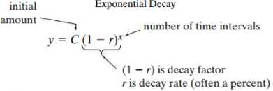

The number of employees at a certain company has been decreasing by $4\%$ per year. If there are $640$ employees now and this trend continues, how many employees will be at the company in $8$ years?