Section 6.6 Graphing Exponential Functions and Using the

Compound Interest Formula

Objective 1: Graphing Exponential Functions

Functions of the form $f\left(x\right)=b^{x}$ where $b$ is a real number such that $b>0$ and $b≠1$ are called exponential functions.

Graph the exponential function by making a table of values.
a.$f\left(x\right)=4^{x}$  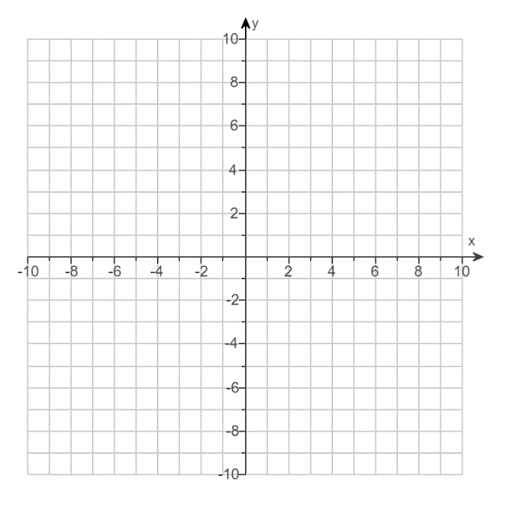 | b. $f\left(x\right)={\left(\frac{1}{4}\right)}^{x}$
Characteristics of Exponential Functions of the Form $f\left(x\right)=b^{x}$ where$b>0$ and$b≠1$:
The function $f$:
- is a one to one function.
- has a domain of all real numbers.
- has a range of $y>0$.
- has a horizontal asymptote of $y=0$.
- is increasing on its entire domain for $b>1$.
- is decreasing on its entire domain for $0<b<1$.

The graph of $f$:
- has a $y$-intercept of $1$.
- has no $x$-intercepts.
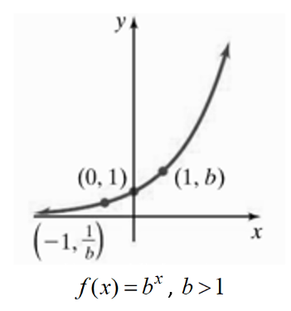 | 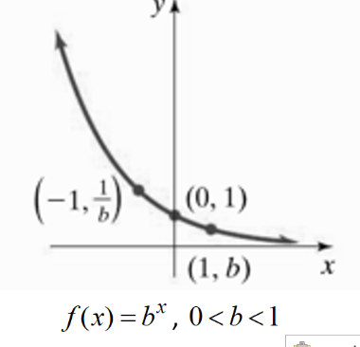

Objective 2: Transformations of Exponential Functions

The family of exponential functions are functions that have graphs that are transformations of the graph of $f\left(x\right)=b^{x}$.

Graph $g$ by using transformations of the graph of an exponential function $f\left(x\right)=b^{x}$. For function $g$, state the domain, the range, the $y$-intercept of its graph, an equation of the horizontal asymptote, and if the function is increasing or decreasing on its domain.

a.$g\left(x\right)=4^{x-2}$ | b. g$\left(x\right)={\left(\frac{1}{4}\right)}^{x}+2$
c.$g\left(x\right)={2⋅3}^{x}-1$ | d. $g\left(x\right)={-\left(\frac{1}{3}\right)}^{x+3}$

Objective 3: Solving Problems Modeled by Exponential Functions

There are many real world situations that can be modeled with exponential functions. For example, populations over a certain time interval can sometimes be modeled with an exponential function.

The function $p\left(t\right)=75{\left(1.095\right)}^{t}$ models the projected population of a city, in thousands, $t$ years since 2020.
a. What was the population of the city in the year 2020?

b. At what rate is the population of the city projected to increase? Give your answer as a percent per year.

c. What is the projected population of the city in the year 2030?

Objective 4: Compound Interest

Another application of exponential functions has to do with interest rates on loans. The compound interest formula $A=P{\left(1+\frac{r}{n}\right)}^{nt}$ calculates the dollars $A$ accrued (or owed) after $P$ dollars are invested (or loaned) at an annual rate of interest $r$ compounded $n$ times each year for $t$ years.

Suppose $\$1000$ is invested at an annual interest rate of $3.75\%$. How much will the investment be worth in $20$ years if the interest is compounded:
d. annually | e. quarterly | f. monthly

