Section 6.4 Special Products

# Objective 1: Squaring Binomials

Squaring a binomial can be visualized geometrically as the area of a square with side length $(a+b)$ where $a$ and $b$ are both positive, real numbers.

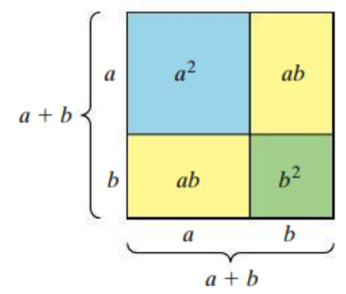

$$Area={\left(a+b\right)}^{2} \\ =(a+b)(a+b) \\ =a^{2}+2ab+b^{2}$$

This leads to two identities that can be used to square a binomial.

$${\left(a+b\right)}^{2}=a^{2}+2ab+b^{2}$$

$${\left(a-b\right)}^{2}=a^{2}-2ab+b^{2}$$

Write the expression as a polynomial in standard form.

|  |  |
| --- | --- |
| a. ${\left(3x+5\right)}^{2}$ | b. ${\left(4m-1\right)}^{2}$ |
| c. $2{\left(x-2y\right)}^{2}$ |  |

# Objective 2: Multiplying the Sum and Difference of Two Terms

Another special product is the product of the sum and difference of the same two terms.

a. Multiply: $(2x+1)(2x-1)$

Notice that the linear terms canceled out, leaving the **difference of squares**. This can be generalized as the following identity.

$$\left(a+b\right)\left(a-b\right)=a^{2}-b^{2}$$

Find the product.

|  |  |
| --- | --- |
| b. $(3x+5)(3x-5)$ | c. $(10a+b)(10a-b)$ |
| d. $(x^{2}-7)(x^{2}+7)$ |  |