Section 5.7 Mean, Median, and Mode

Objective 1: Calculating Mean, Median, and Mode

When analyzing a set of data, it is often useful to use a measure of central tendency which is a number that describes the middle of the data set.

One common measure of central tendency is the mean of a set of data, often denoted by $\overline{x}$. The mean is calculated by dividing the sum of the items by the number of items.

Another measure of central tendency is the median. The median of a data set is the middle number when the numbers are arranged in ascending (or descending) order. If the number of items is even, the median is the mean of the two middle numbers.

A third measure of central tendency is the mode. The mode of a data set is the number that occurs most often. A data set can have more than one mode if there are multiple numbers that appear with the same frequency. If no number in a data set appears more than once, that data set does not have a mode.

a. The 40-yard dash times, in seconds, for 10 athletes are given below. Find the mean, median, and mode.

$$5.6, 5.4, 5.0, 4.6, 4.7, 5.4, 4.7, 5.1, 4.9, 4.7$$

The box plots below show the ticket prices of two theaters.
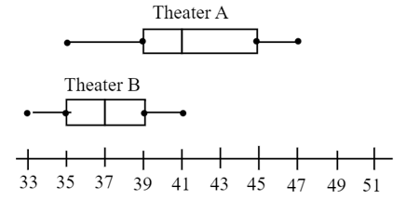
b. What is the median ticket price for each theater?

c. What is the highest ticket price at each theater?

d. Which theater has a greater range of prices?

