Section 5.5 Systems of Linear Inequalities

Just as a system of linear equations is made up of two or more linear equations, a system of linear inequalities is composed of two or more linear inequalities.

A solution of a system of linear inequalities is an ordered pair that satisfies each inequality in the system. The set of all such ordered pairs is the solution set of the system.

Objective 1: Graphing Systems of Linear Inequalities

The solution set of a system of linear inequalities can best be represented with a graph.

Graph the solution set of the system of linear inequalities.

a. $\left\{\begin{aligned}y≥4x \\ x+3y>9\end{aligned}\right.$  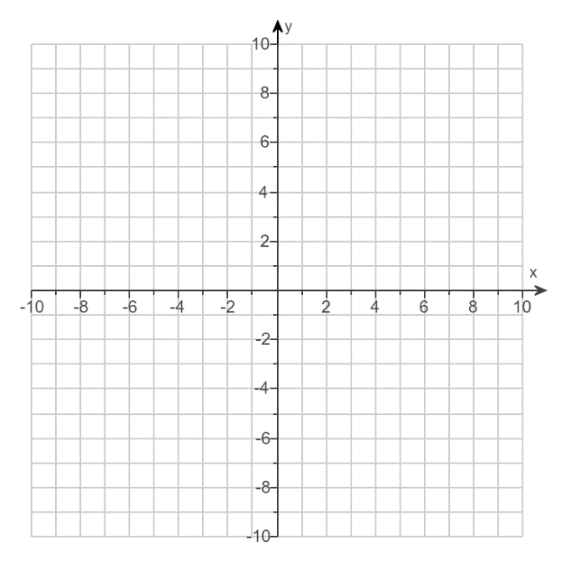 | b. $\left\{\begin{aligned}3x-2y<4 \\ x≤-1\end{aligned}\right.$
c. $\left\{\begin{aligned}y≤5x-3 \\ y≤x+4\end{aligned}\right.$ | d. $\left\{\begin{aligned}2x-y≤7 \\ x>3 \\ y≥3\end{aligned}\right.$

Objective 2: Modeling with Systems of Linear Inequalities

Franklin High School is planning to take students to a play at a community theater. The theater can hold no more than $240$ people. For every $5$ students, there must be at least one adult.

a. Let $x$ represent the number of students and let $y$ represent the number of adults. Write a system of linear inequalities that models this situation.
b. Graph the solution set of the system of inequalities.

