Section 5.1 Solving Systems of Linear Equations by Graphing

# Objective 1: Determining Whether an Ordered Pair is a Solution

A system of linear equations consists of two or more linear equations. In this course, we focus on solving systems of linear equations containing two equations in two variables.

Recall that a solution of an equation in two variables is an ordered pair $(x,y)$ that makes the equation true. A **solution of a system** of two equations in two variables is an ordered pair $(x,y)$ that makes both equations true.

Determine whether the ordered pair $(5,4)$ is a solution of the system $\left\{\begin{aligned}2x-5y=-10 \\ 2x+4y=6\end{aligned}\right.$.

# Objective 2: Solving Systems of Linear Equations by Graphing

Since a solution of a system of two equations in two variables is a solution common to both equations, it is also a point common to the graphs of both equations. We can estimate the solution(s) of a system of equations by graphing each equation on the same coordinate system and estimating the coordinates of any point of intersection.

a. Solve the system by graphing.

$\left\{\begin{aligned}-2x+y=-5 \\ 2x-4y=8\end{aligned}\right.$

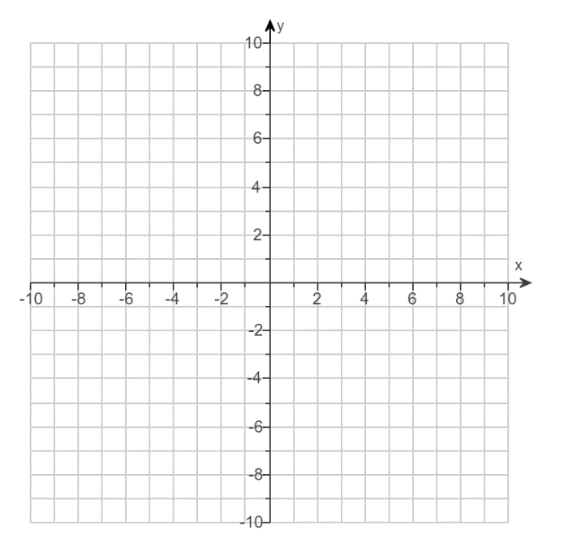

A system of two linear equations can have one solution, no solution, or infinitely many solutions.

Solve each system by graphing.

|  |  |
| --- | --- |
| b. $\left\{\begin{aligned} 2x-y=6 \\ 6x-3y=6\end{aligned}\right.$ | c. $\left\{\begin{aligned} 2x-y=6 \\ 6x-3y=18\end{aligned}\right.$ |

