Section 3.8

Graphing Piecewise-Defined Functions and Shifting and Reflecting Graphs of Functions

# Objective 1: Graphing Piecewise-Defined Functions

A **piecewise-defined function** is a function defined by two or more expressions.

Graph the piecewise-defined function.

|  |  |
| --- | --- |
| a.  Blank coordinate plane that spans from negative ten to positive ten on each axis with a scale of one unit. | b. g  Blank coordinate plane that spans from negative ten to positive ten on each axis with a scale of one unit. |

c. Consider the function $f\left(x\right)=|x|$. Complete the table and then use the table to graph $f$.

|  |  |  |  |  |  |
| --- | --- | --- | --- | --- | --- |
| $$x$$ | $$-2$$ | $$-1$$ | $$0$$ | $$1$$ | $$2$$ |
| $$f\left(x\right)$$ |  |  |  |  |  |

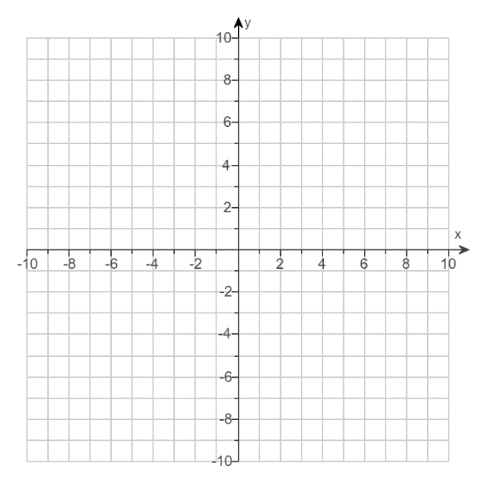

The absolute value function, $f\left(x\right)=|x|$, can also be written as a piecewise-defined function.

$$f\left(x\right)=\left|x\right|=\left\{\begin{aligned}-x, &x<0 \\ x, &x≥0\end{aligned}\right.$$

# Objective 2: Vertical and Horizontal Shifting

Consider the functions $f\left(x\right)=|x|$ and $g\left(x\right)=\left|x\right|+3$.

a. Complete the table, and then graph $f$ and $g$ on the same axes.

|  |  |  |
| --- | --- | --- |
| $$x$$ | $$f\left(x\right)$$ | $$g(x)$$ |
| $$-2$$ |  |  |
| $$-1$$ |  |  |
| $$0$$ |  |  |
| $$1$$ |  |  |
| $$2$$ |  |  |

b. Describe the relationship between the graph of $f$ and the graph of $g$.

**Vertical Shifts:**

Let $c$ be a positive number.

* The graph of $g\left(x\right)=f\left(x\right)+c$ is the graph of $y=f(x)$ shifted $c$ units upward.
* The graph of $g\left(x\right)=f\left(x\right)-c$ is the graph of $y=f\left(x\right)$ shifted $c$ units downward.

c. Graph $h\left(x\right)=\left|x\right|-5$.



Consider the functions $f\left(x\right)=|x|$ and $g\left(x\right)=\left|x-2\right|$.

d. Complete the table, and then graph $f$ and $g$ on the same axes.

|  |  |  |
| --- | --- | --- |
| $$x$$ | $$f\left(x\right)$$ | $$g(x)$$ |
| $$-2$$ |  |  |
| $$-1$$ |  |  |
| $$0$$ |  |  |
| $$1$$ |  |  |
| $$2$$ |  |  |
| $$3$$ |  |  |
| $$4$$ |  |  |

e. Describe the relationship between the graph of $f$ and the graph of $g$.

**Horizontal Shifts:**

Let $c$ be a positive number.

* The graph of $g\left(x\right)=f\left(x-c\right)$ is the graph of $y=f(x)$ shifted $c$ units to the right.
* The graph of $g\left(x\right)=f\left(x+c\right)$ is the graph of $y=f\left(x\right)$ shifted $c$ units to the left.

Graph each function.

|  |  |
| --- | --- |
| f.  Blank coordinate plane that spans from negative ten to positive ten on each axis with a scale of one unit. | g.  Blank coordinate plane that spans from negative ten to positive ten on each axis with a scale of one unit. |

# Objective 3: Reflecting Graphs.

Consider the functions $f\left(x\right)=|x|$ and $g\left(x\right)=-\left|x\right|$.

a. Complete the table, and then graph $f$ and $g$ on the same axes.

|  |  |  |
| --- | --- | --- |
| $$x$$ | $$f\left(x\right)$$ | $$g(x)$$ |
| $$-2$$ |  |  |
| $$-1$$ |  |  |
| $$0$$ |  |  |
| $$1$$ |  |  |
| $$2$$ |  |  |

b. Describe the relationship between the graph of $f$ and the graph of $g$.

**Reflection about the $x$-axis:**

The graph of $g\left(x\right)=-f(x)$ is the graph of $y=f\left(x\right)$ reflected about the $x$-axis.

c. Graph $h\left(x\right)=-\left|x+4\right|-2$.

