Section 3.7 Graphing Linear Functions

# Objective 1: Graphing Linear Functions

We know from the previous section, that all linear equations are functions except those of the form $x=c$, which are vertical lines. In general, a **linear function** is a function that can be written in the form $f\left(x\right)=mx+b$.

a. Graph the linear functions $f\left(x\right)=-2x$ and $g\left(x\right)=-2x+6$ on the same axes.

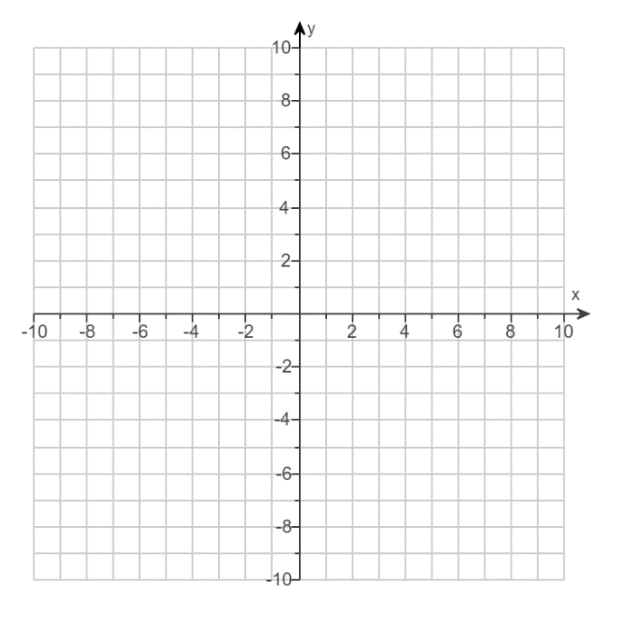

b. Graph the linear function $f\left(x\right)=\frac{1}{4}x-2$ by finding the $x$- and $y$-intercepts.



# Objective 2: Deciding Whether a Situation is a Linear Function

To find the perimeter, $y$, of a regular triangle given its side length $x$, multiply $x$ by $3$.

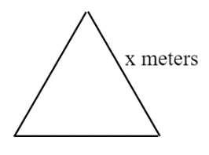

a. Complete the table.

|  |  |  |  |  |  |
| --- | --- | --- | --- | --- | --- |
| Side length, $x$ (in meters) | $$1$$ | $$3$$ | $$\frac{1}{3}$$ | $$9$$ | $$7$$ |
| Perimeter of triangle, $y$ (in meters) |  |  |  |  |  |

b. Graph the data from part a.



c. Is this situation described by a linear function?