Section 3.6 Functions

# Objective 1: Identifying Relations, Domains, and Ranges

In previous sections, we have discussed relationships between two quantities. For example, the relationship between the length of the side of a square $x$ and its area $y$ is described by the equation $y=x^{2}$.

A set of ordered pairs is called a **relation**. The set of all $x$-coordinates is called the **domain** of a relation, and the set of all $y$-coordinates is called the **range** of a relation. Equations such as $y=x^{2}$ are also called relations since equations in two variables define a set of ordered pair solutions.

# Objective 2: Identifying Functions

Some relations are also **functions**. A function is a set of ordered pairs that assigns to each $x$-value exactly one $y$-value.

State the domain and range of the given relation. Then determine if the relation is also a function.

|  |  |
| --- | --- |
| a. $\left\{\left(4,-4\right), \left(-3,-4\right), \left(9,0\right)\right\}$ | b. $\{\left(0,5\right), \left(3, 0\right), \left(-2,10\right), \left(0,-8\right)\}$ |

Relations and functions can be described by a graph of their ordered pairs.

c. Is the graph shown the graph of a function?

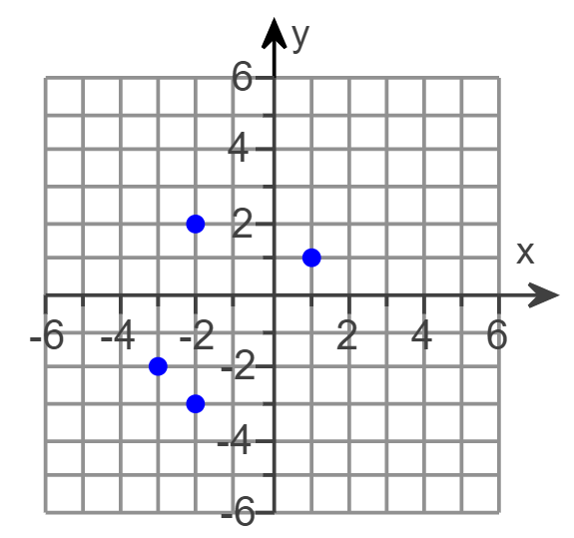

# Objective 3: Using the Vertical Line Test

When an $x$-coordinate is paired with more than one $y$-coordinate, a vertical line can be drawn that will intersect the graph at more than one point. We can use this fact to determine whether a relation is also a function. We call this the **vertical line test**.

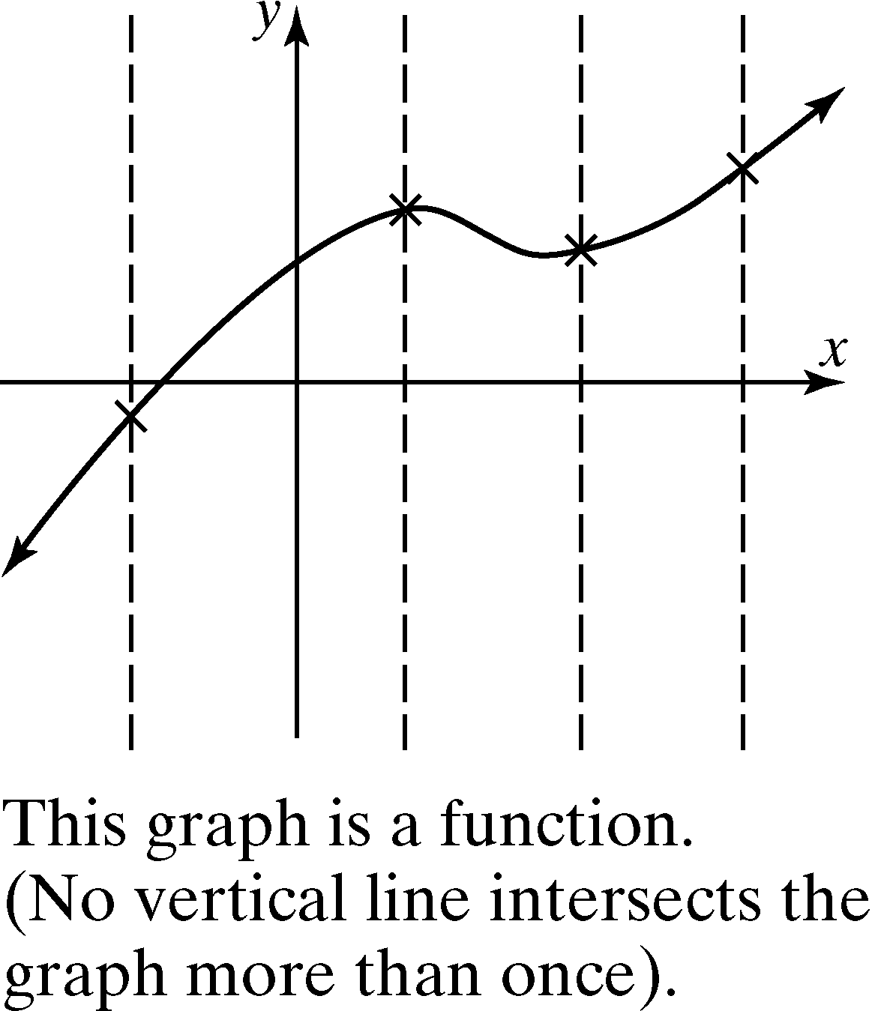 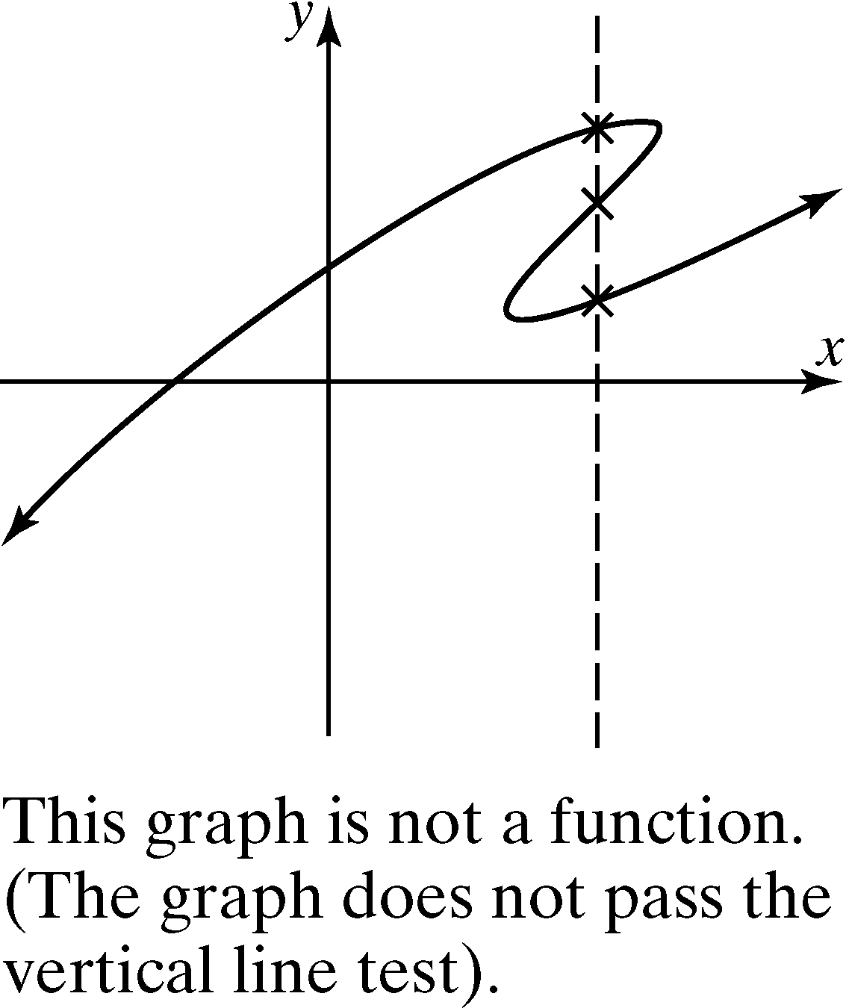

**Vertical Line Test:**

If a vertical line can be drawn so that it intersects a graph more than once, the graph is not the graph of a function.

Recall that the graph of a linear equation is a line, and a line that is not vertical will pass the vertical line test. Thus, all linear equations are functions except those of the form $x=c$, which are vertical lines.

Determine whether the equation describes a function.

|  |  |
| --- | --- |
| a. $y-5x=3$ | b. $x=2$ |

# Objective 4: Using Function Notation

Consider the linear equation $y=2x+1$. This linear equation describes a function because every $x$-coodinate is paired with one $y$-coordinate. The variable $y$ is a function of the variable $x$. We say the variable $x$ is the **independent variable** because any value in the domain can be assigned to $x$. The variable $y$ is the **dependent variable** because its value depends on $x$.

The symbol $f(x)$ means function of $x$ and is read “ $f$ of $x$.” This notation is called **function notation**. The equation $y=2x+1$ can be written as $f\left(x\right)=2x+1$ using function notation. These equations have the same meaning. In other words, $y=f\left(x\right).$

The notation $f(1)$ means replace $x$ with $1$ and find the resulting $y$ or function value.

$$f\left(x\right)=2x+1$$

$$f\left(1\right)=2\left(1\right)+1=3$$

Since $f\left(1\right)=3$, we know the ordered pair $(1,3)$ is a point on the graph of the linear function $f\left(x\right)=2x+1$.

Consider the function $f\left(x\right)=x^{2}+3$. Find:

|  |  |  |
| --- | --- | --- |
| a. $f\left(-4\right)$ | b. $f\left(0\right)$ | c. $f(5)$ |