Section 3.5 Equations of Lines

# Objective 1: Using Slope-Intercept Form to Write a Linear Equation

Recall that the form $y=mx+b$ is called the slope-intercept form of a linear equation because $m$ is the slope of the line and the point $(0,b)$ is the $y$-intercept of the line.

The slope-intercept form can be used to write the equation of a line when its slope and $y$-intercept are known.

Find the equation of the line with slope $-\frac{4}{5}$ and $y$-intercept of $(0,7)$.

# Objective 2: Using Slope-Intercept Form to Graph a Linear Equation

We can also use the slope-intercept form of the equation of a line to graph a linear equation.

Use the slope-intercept form to graph the equation $7x+5y=20$.

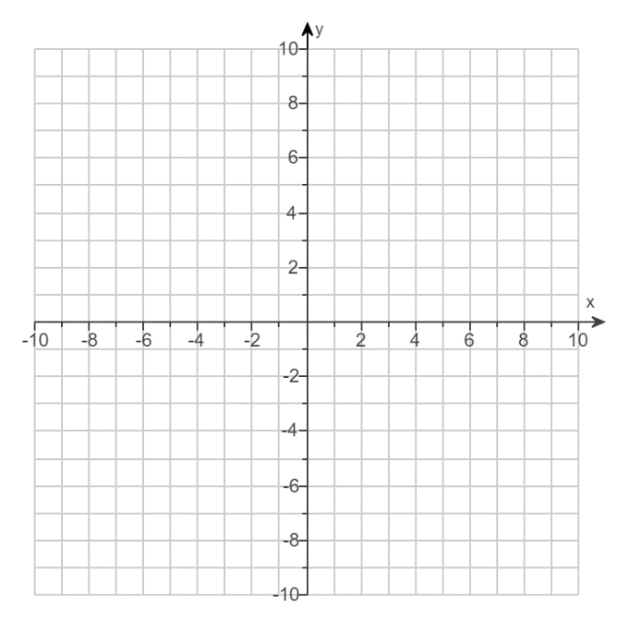

# Objective 3: Writing a Linear Equation Given the Slope and a Point

Given the slope and any point on a line, we can write its equation using the point-slope form of the equation of a line. This form can be derived from the slope formula. Suppose we are given the slope $m$ of a line and a point $(x_{1},y_{1})$ on the line, and $(x,y)$ is any other point on the line.

$$\frac{y-y_{1}}{x-x_{1}}=m$$

$$y-y_{1}=m(x-x_{1})$$

This is the **point-slope form** of the equation of a line.

Find the equation of the line that has a slope of $-3$ and passes through the point $(-2,-8)$. Give the equation in standard form.

# Objective 4: Writing a Linear Equation Given Two Points

When given two points on a line, we can find the equation by first finding the slope and then writing the equation in point-slope form.

Find the equation of the line that passes through the points $(-4,7)$ and $(-6,-6)$. Give the equation in standard form.

# Objective 5: Writing Equations of Vertical and Horizontal Lines

Recall from section 3.3 that vertical lines have equations of the form $x=c$ and horizontal lines have equations of the form $y=c$.

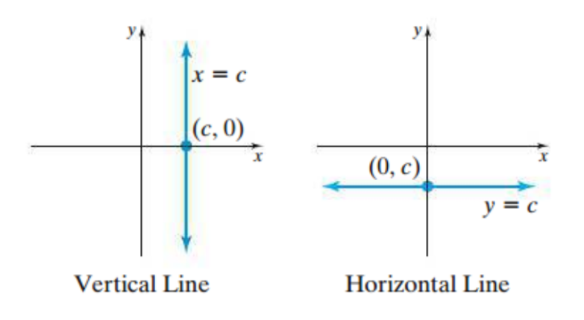

a. Find the equation of the vertical line that passes through the point $\left(-5,8\right).$

b. Find the equation of the horizontal line that passes through the point $\left(-5,8\right).$

# Objective 6: Using Linear Equations to Solve Problems

Many real-world situations can be modeled with linear equations in two variables.

A web-based t-shirt company has learned that by pricing a t-shirt at $\$10$, its sales will reach $2000$ t-shirts per day. Raising the price to $\$15$ will cause its sales to fall to $1500$ t-shirts per day.

a. Assuming the relationship between sales price and the number of t-shirts sold per day is linear, write an equation that models this relationship.

b. Predict the daily sales of t-shirts if the price is $\$12$.