Section 3.2 Graphing Linear Equations

# Objective 1: Identifying Linear Equations

Consider the equation $x-2y=6$. Five solutions of the equation are shown on the graph below.

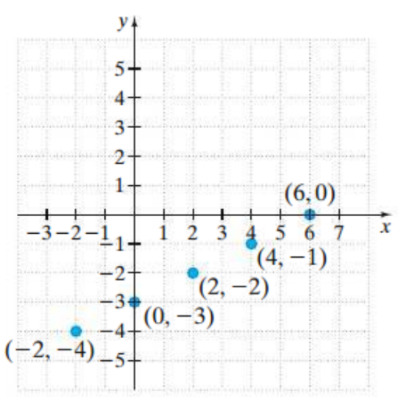

Notice that these solutions all lie on the same line. Every ordered pair solution of the equation corresponds to a point on this line, and every point on this line corresponds to an ordered pair solution. Thus, we say that this line is the **graph of the equation $x-2y=6$** .

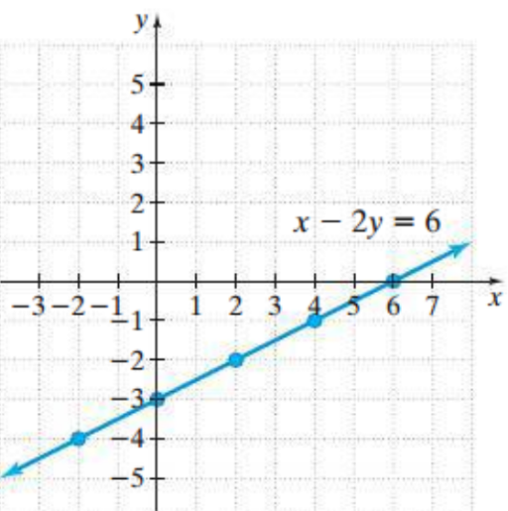

The equation $x-2y=6$ is called a **linear equation in two variables**. The graph of every linear equation in two variables is a line.

**Linear Equation in Two Variables:**

A linear equation in two variables is an equation that can be written in the form

$$Ax+By=C$$

where $A, B,$ and $C$ are real numbers and $A$ and $B$ are not both $0$.

The form $Ax+By=C$ is called **standard form**.

Determine whether each equation is a linear equation in two variables.

|  |  |
| --- | --- |
| a. $3x+2y=9$ | b. $3x+y^{2}=9$ |
| c. $-2x=y-3$ | d. $x=5$ |

# Objective 2: Graphing Linear Equations by Plotting Ordered Pair Solutions

In order to graph a linear equation in two variables, we must know a minimum of two solutions of the equation.

a. Consider the linear equation $y=-3x+4$. Find three ordered pair solutions by completing the table. Then use the ordered pairs to graph the equation.

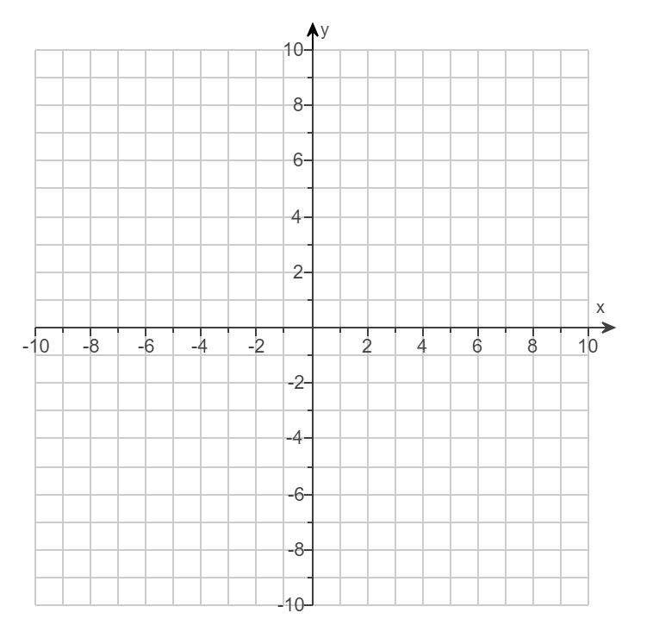

|  |  |
| --- | --- |
| $$x$$ | $$y$$ |
| $$-2$$ |  |
| $$0$$ |  |
| $$2$$ |  |

Graph each linear equation by finding at least two ordered pair solutions.

|  |  |
| --- | --- |
| b. Blank coordinate plane that spans from negative ten to positive ten on each axis with a scale of one unit. | c.  Blank coordinate plane that spans from negative ten to positive ten on each axis with a scale of one unit. |
| d.  Blank coordinate plane that spans from negative ten to positive ten on each axis with a scale of one unit. |  |

.

e. Graph the linear equations $y=\frac{1}{3}x$ and $y=\frac{1}{3}x-2$ on the same coordinate plane. Then, compare the two graphs.



The graph of $y=mx+b$ crosses the $y$-axis at $\left(0,b\right).$