Section 3.1 Reading Graphs and the Rectangular Coordinate System

# Objective 1: Defining the Rectangular Coordinate System and Plotting Ordered Pairs of Numbers

In the year 2000, the college enrollment in the United States was $15.3$ million. We can represent this information as an **ordered pair $(2000, 15.3)$** where the first number represents the year and the second number represents the U.S. college enrollment, in millions, for that year. It is called an ordered pair because the order does matter. We use the notation $(x, y)$ to represent an ordered pair. Notice that the $x$-coordinate is first, followed by the $y$-coordinate listed second.

We can represent an ordered pair graphically using the **rectangular coordinate system**, also called the **Cartesian coordinate system**. The plane used in this system is called the **coordinate plane** or **Cartesian plane**. The horizontal axis ($x$-axis) and the vertical axis ($y$-axis) intersect at the **origin** *O* and divide the coordinate plane into four quadrants labeled quadrants I, II, III and IV. The quadrants are numbered counterclockwise beginning with quadrant I in the upper right.

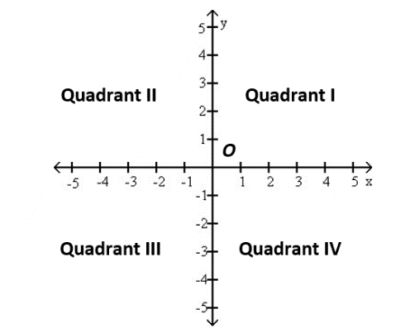

To plot the point corresponding to the ordered pair $(a, b)$, start at the origin. Move $a$ units left or right (left if $a$ is negative and right if $a$ is positive). From there, move $b$ units down or up (down if $b$ is negative and up if $b$ is positive).

For example, to plot the point corresponding to the ordered pair $(-2, 3)$, go $2$ units to the left of the origin on the $x$-axis then move $3$ units up parallel to the $y$-axis. The point corresponding to the ordered pair $(-2, 3)$ is located in Quadrant II.

Plot each ordered pair on the coordinate plane. State in which quadrant or on which axis each point lies.

|  |  |
| --- | --- |
| a. | Blank coordinate plane that spans from negative ten to positive ten on each axis with a scale of one unit. |
| b. |
| c. |
| d. |

# Objective 2: Graphing Paired Data

Data that can be represented as an ordered pair is called **paired data**. Many types of data collected from the real world are paired data. The graph of paired data as points in the rectangular coordinate system is called a **scatter diagram**. Scatter diagrams can be used to look for patterns and trends in paired data.

The table below gives the approximate annual number of wildfires (in thousands) that occurred in the United States for the years shown.

|  |  |
| --- | --- |
| **Year** | **Number of wildfires (in thousands)** |
| 2000 | 92 |
| 2005 | 67 |
| 2010 | 72 |
| 2015 | 68 |
| 2020 | 59 |

a. Write this paired data as a set of ordered pairs of the form (year, number of wildfires in thousands).

b. Create a scatter diagram of the paired data.



A scatter diagram, or scatter plot, can be used to determine whether two quantities are related. If there is a clear relationship, the quantities are said to be **correlated**. A measure that is used to describe the strength and direction of a relationship between variables whose data points lie on or near a line is called the **correlation coefficient**, designated by $r$. Figures (a) through (g) show scatter plots and correlation coefficients.

(a) points lie on a line with positive slope, r = 1, perfect positive correlation
(b) points lie near a line with positive slope, r = 0.8, strong positive correlation
(c) points are scattered about a line with positive slope, r = 0.3, moderate to weak, positive correlation
(d) points are scattered at random, r = 0, no correlation
(e) points are scattered about a line with negative slope, r = -0.3, moderate to weak, negative correlation
(f) points lie near a line with negative slope, r = -0.8, strong negative correlation
(g) points lie on a line with negative slope, r = -1, perfect negative correlation

# Objective 3: Determining Whether an Ordered Pair is a Solution

# The linear equation in one variable $x+1=5$ has one solution, $4$, because $4$ is the only value of the variable $x$ that makes the equation true.

# A linear equation in two variables such as $2x+y=8$ has infinitely many solutions consisting of two values, one for $x$ and one for $y$. For example, $x=3$ and $y=2$ is a solution of the equation because substituting these values for the variables results in a true number sentence.

# For $x=3$ and $y=2$, $2x+y=2\left(3\right)+2=8$.

The solution can be written as the ordered pair $(3,2)$.

Determine whether each ordered pair is a solution of the equation $2x+y=8$.

|  |  |
| --- | --- |
| a. $\left(-\frac{1}{2}, 7\right)$ | b. $(8,0)$ |
| c. $(5,-2)$ | d. $\left(\frac{3}{4},\frac{13}{2}\right)$ |

# Objective 4: Completing Ordered Pair Solutions

# If one value of an ordered pair solution of an equation is known, the other value can be determined. To find the unknown value, replace one variable in the equation with its known value and then solve for the unknown value.

Complete the ordered pair solutions for the equation $x-2y=-6$.

|  |  |
| --- | --- |
| a. $\left(____, 2\right)$ | b. $(-6,____)$ |

Solutions of equations in two variables can also be recorded in a table of values.

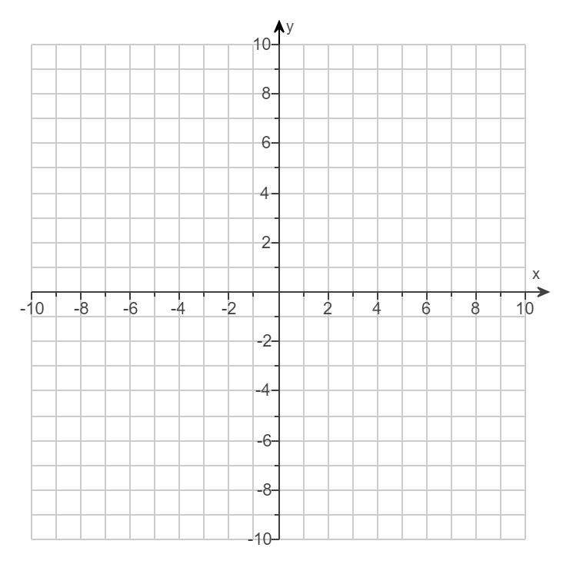c. Complete the table of ordered pairs for the linear equation $x=-2y$. Then plot the ordered pair solutions.

|  |  |
| --- | --- |
| $$x$$ | $$y$$ |
|  | $$5$$ |
|  | $$0$$ |
| $$10$$ |  |