Section 10.4a Quadratic Functions and Their Graphs

In previous sections, we solved quadratic equations. We will now study **quadratic functions** and their graphs.

**Quadratic Function**

A quadratic function is a function that can be written in the form $f\left(x\right)=ax^{2}+bx+c$ where $a,$ $b$, and $c$ are real numbers and $a≠0$.

# Objective 1: Graphing $f\left(x\right)={ax}^{2}$

To graph the quadratic equation $y=x^{2}$, we can make a table of values and use those points to draw the graph.

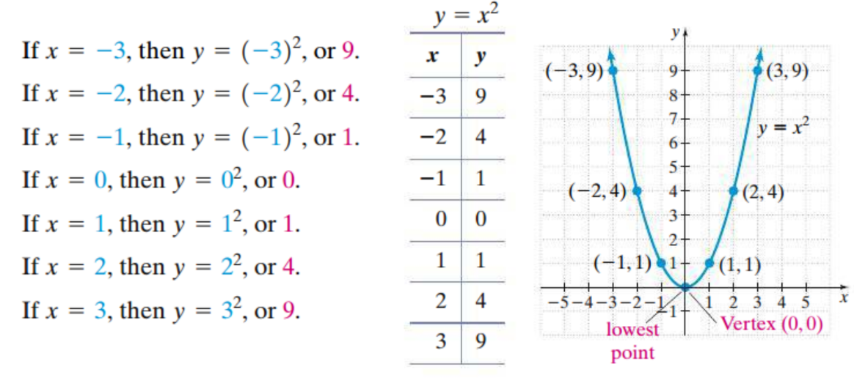

This curve is called a **parabola**. The lowest point on a parabola opening upward is called the **vertex**. The graph of a parabola is symmetric about the vertical line that passes through its vertex. The axis of symmetry for the graph of $y=x^{2}$ is the $y$-axis, or the line $x=0$.

Consider the quadratic function $f\left(x\right)=-2x^{2}$.

a. Complete the table and graph $f$.

|  |  |
| --- | --- |
| $$x$$ | $$f(x)$$ |
| $$-2$$ |  |
| $$-1$$ |  |
| $$0$$ |  |
| $$1$$ |  |
| $$2$$ |  |

b. State the vertex and axis of symmetry of the graph of $f$.

c. Describe the transformations required to graph $f$ starting from the graph of $y=x^{2}$.

# Objective 2: Graphing $f\left(x\right)=x^{2}+k$

Consider the functions $f\left(x\right)=x^{2}$ and $g\left(x\right)=x^{2}-2$.

a. Graph $f$ and $g$ on the same axes.

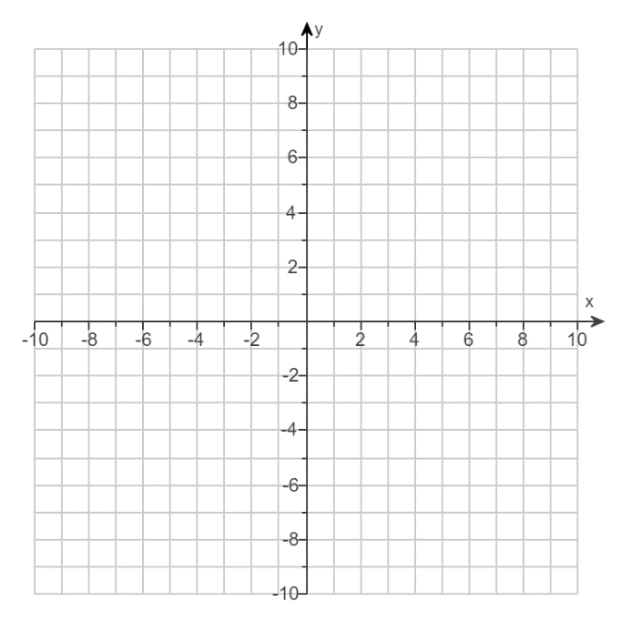

b. State the vertex and axis of symmetry of the graphs of $f$ and $g$.

c. Describe the graph of $g$ as a transformation of the graph of $f$.

# Objective 3: Graphing $f\left(x\right)={a(x-h)}^{2}+k$

All quadratic functions can be graphed by using transformations of the graph of $y=x^{2}$. In order to precisely graph a quadratic function, you need a minimum of three points, one of which is the vertex.

a. Graph $f\left(x\right)=\frac{1}{4}{\left(x-4\right)}^{2}+3$. State the vertex and the axis of symmetry of the graph of $f$.



**Graph of a Quadratic Function Written in the Form $f\left(x\right)=a{\left(x-h\right)}^{2}+k$**

The graph of a quadratic function written in the form $f\left(x\right)=a{\left(x-h\right)}^{2}+k$ is a parabola with vertex $(h,k)$. If $a>0$, the parabola opens upward. If $a<0$, the parabola opens downward. The axis of symmetry is the line defined by the equation $x=h$.

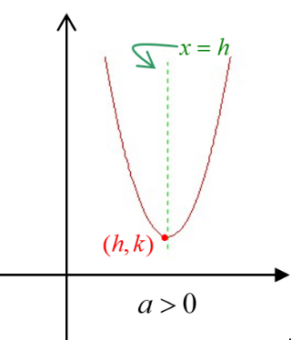 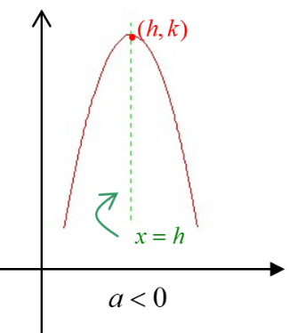

b. Graph $f\left(x\right)=-{\left(x+1\right)}^{2}+5$. State the vertex and the axis of symmetry of the graph of $f$.

