8.7 The Cost of Home Ownership
Objective 1: Compute the monthly payment and interest costs for a mortgage
A mortgage is a long-term installment loan for the purpose of buying a home. The property is pledged as security for payment. The down payment is the portion of the sale price of the home that the buyer initially pays to the seller. The amount of the mortgage is the difference between the sale price and the down payment. Monthly payments are calculated the same way as for car loans and other installment loans.
Mortgages can have a fixed interest rate or a variable interest rate. Fixed-rate mortgages have the same monthly payment during the entire time of the loan. Variable-rate mortgages have payment amounts that change from time to time depending on changes in the interest rate.
Most lending institutions require the buyer to pay one or more points at the time of closing—that is, the time at which the mortgage begins. A point is a one-time charge that equals 1% of the loan amount. For example, two points means that the buyer must pay 2% of the loan amount at closing.
LOAN PAYMENT FORMULA FOR FIXED INSTALLMENT LOANS

The regular payment amount, PMT, required to repay a loan of P dollars paid n times per year over t years at an annual rate r is

$PMT=\frac{P\left(\frac{r}{n}\right)}{\left[1-{\left(1+\frac{r}{n}\right)}^{-nt}\right]} .$

Objective 2: Prepare a partial loan amortization schedule
When a loan is paid off through a series of regular payments, it is said to be amortized. The interest is computed using the simple interest formula I = Prt. The principal, P, is equal to the balance of the loan which changes each month. The interest rate, r, is the annual mortgage rate and t is 1/12 of a year. A document showing how the payment each month is split between interest and principal is called a loan amortization schedule.
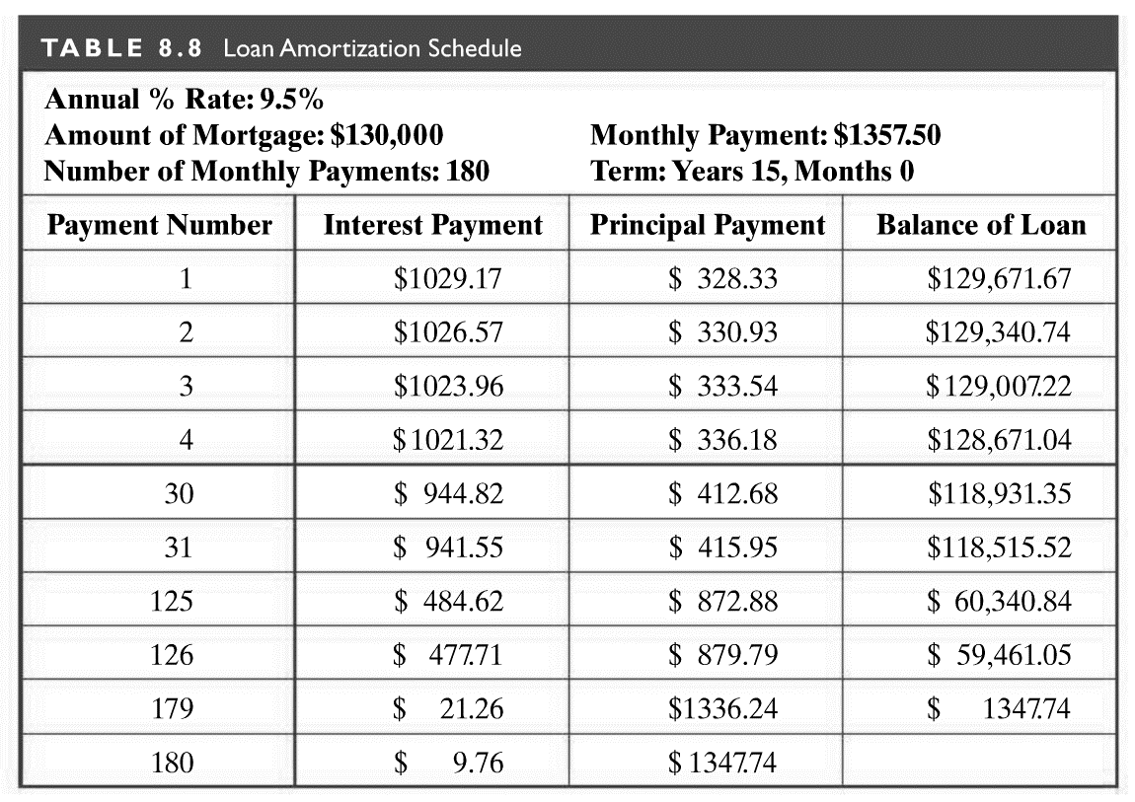

Payment  Number | Interest | Principal | Loan  Balance
1
2
3

Objective 3: Determine what you can afford to spend for a mortgage
Many financial advisors recommend spending no more than 28% of gross monthly income for mortgage payments and no more than 36% of gross monthly income for total monthly debt including mortgage payments, car payments, credit card bills, student loans, and medical debt.

Objective 4: Understand the pros and cons of renting vs. buying
Renting is generally less costly than buying a home when staying in it for fewer than three years. When looking at a seven-year time frame, the total cost of renting (monthly rent, renter’s insurance, and loss of potential interest on a security deposit) can be more than twice the total cost of buying for homeowners who itemize their tax deductions.
BENEFITS OF RENTING | BENEFITS OF BUYING
No down payment or points are required. Security deposit is generally refundable.  Easy to relocate when lease expires.  Does not tie up money that might be invested more safely and lucratively elsewhere.  May involve lower monthly expenses.  Avoids the risk of falling housing prices.  Home repair, maintenance, and landscaping are generally landlord responsibilities.  There are no property taxes. | Peace of mind and stability. Allows for freedom to remodel, landscape, and redecorate.  Provides significant tax advantages, including deduction of mortgage interest and property taxes.  There is no chance of rent increasing over time.  As the mortgage is paid off, the homeowner builds equity in the house.  The possibility of home appreciation is a potential source of cash in the form of home equity loans.

