Section 6.3 Volume by Slicing

# Topic 1: General Slicing Method

We have seen how integration can be used to compute the area of two-dimensional regions bounded by curves. We now expand this “slice-and-sum” method to finding the volume of three-dimensional solids.

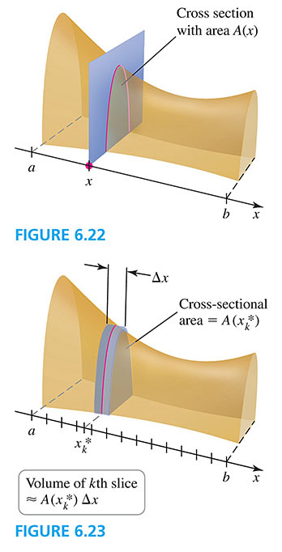 

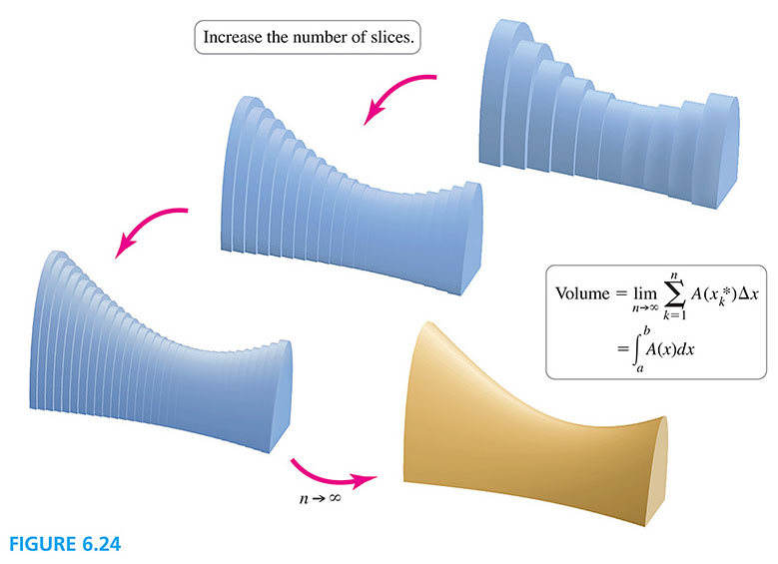

**General Slicing Method**

Suppose a solid object extends from  to  and the cross section of the solid perpendicular to the *x*-axis has an area given by a function *A* that is integrable on . The volume of the solid is

.

# Topic 2: The Disk Method

Consider the shaded region *R* shown below. When *R* is rotated about an axis (in this case the *x*-axis), it forms a three dimensional **solid of revolution**.

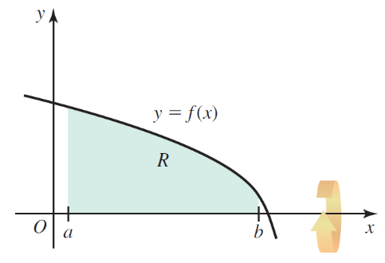 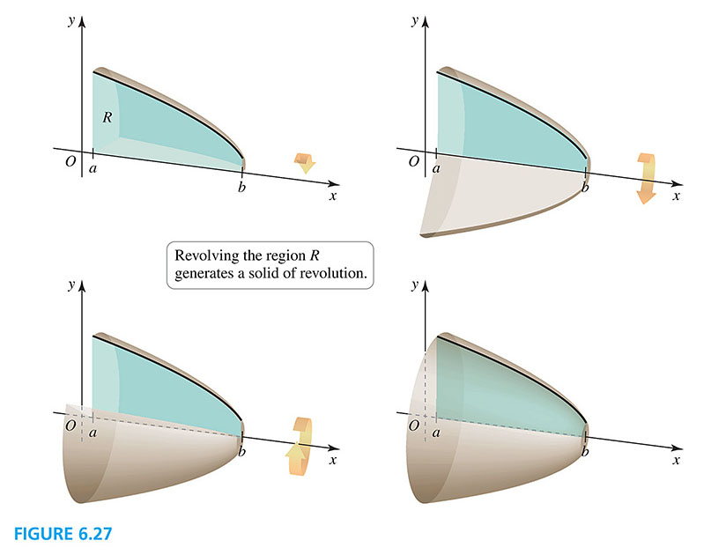

The volume of this solid can be found using the general slicing method.

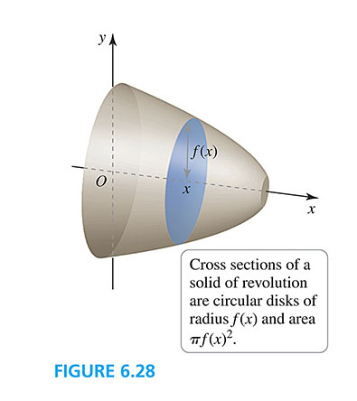

**Disk Method about the *x*-Axis**

Let *f* be continuous with  on the interval . If the region *R* bounded by the graph of *f*, the *x*-axis, and the lines  and  is revolved about the $x$-axis, the volume of the resulting solid of revolution is

.

The two graphs below illustrate the Disk Method about the *x*-axis.

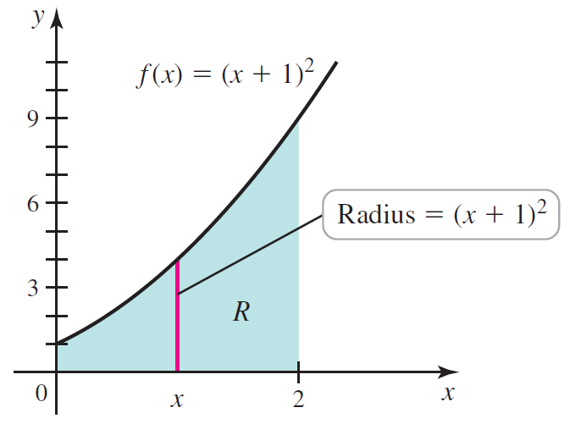

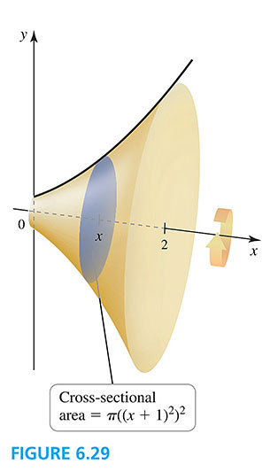

# Topic 3: The Washer Method

When a region R lying above the *x*-axis is revolved around the *x*-axis, the result is a solid with a tubular hole, as illustrated below.

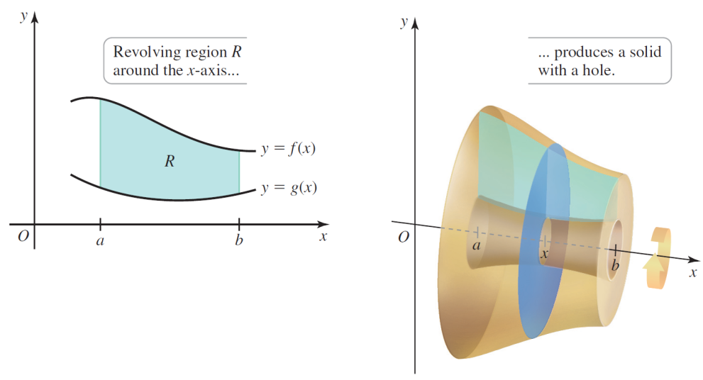 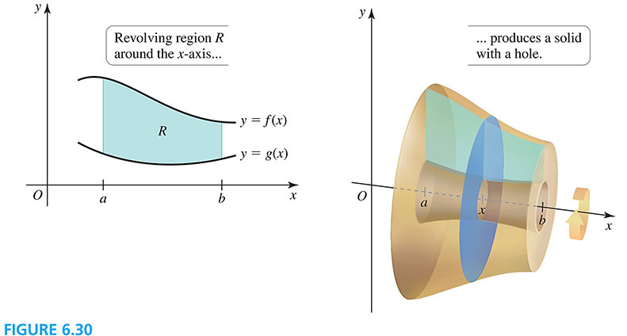 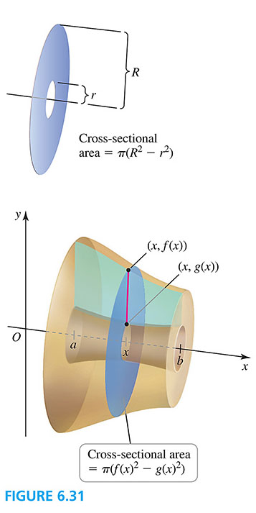

**Washer Method about the *x*-Axis**

Let *f* and *g* be continuous functions with  on the interval . If the region *R* bounded by the graphs of *f*, *g*, and the lines  and  is revolved about the *x*-axis, the volume of the resulting solid of revolution is

.

The two graphs below illustrate the Washer Method about the *x*-axis.

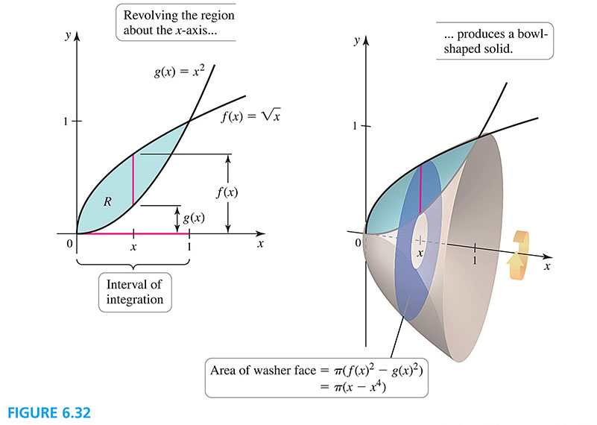

# Topic 4: Revolving about the *y*-Axis

The figures below show the resulting solid of revolution when a region *R* is revolved around the *y*-axis.

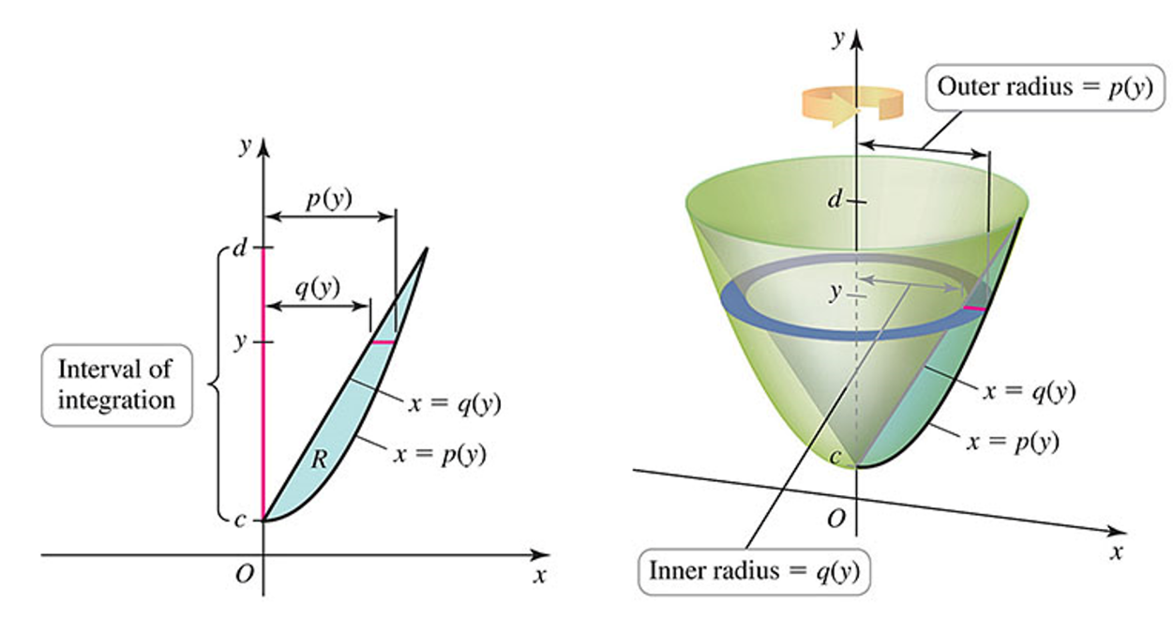

**Disk and Washer Methods about the *y*-Axis**

Let *p* and *q* be continuous functions with  on the interval  . If the region *R* bounded by the graphs of , , and the lines  and  is revolved about the *y*-axis, the volume of the resulting solid of revolution is

.

If , the disk method is used, and the volume is given by



The figures below illustrate the Disk Method about the *y*-axis.

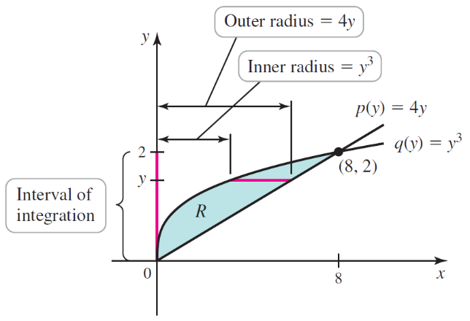 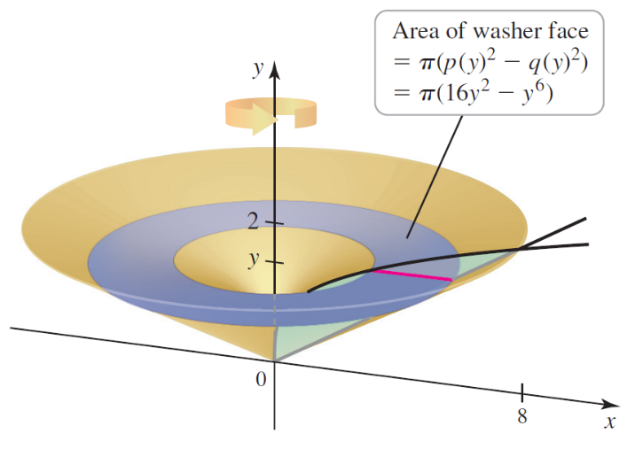

# Topic 5: Revolving about Other Lines

