Section 6.1 Area Between Curves

# Topic 1: Area Between Two Curves

In this section, we are interested in using the definite integral to find the actual area between a curve and the *x*-axis or the actual area between two curves. These areas are always nonnegative quantities. The area measure is never negative.

**Theorem: Area Between Two Curves**

If *f* and *g* are continuous and  over the interval , then the area bounded by  and  for  is given exactly by

.

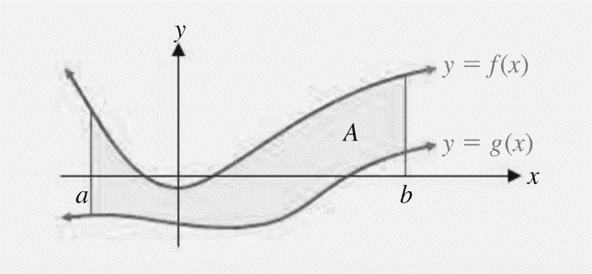

**Topic 2: Income Distribution Application**

The U.S. Census Bureau compiles and analyzes a great deal of data having to do with the distribution of income among families in the Unites States. The **Lorenz curve**, generally found by regression analysis, is a graphical representation of the distribution of income. The variable $x$ represents the cumulative percentage of families at or below a given income level, and the variable $y$ represents the cumulative percentage of total family income received.

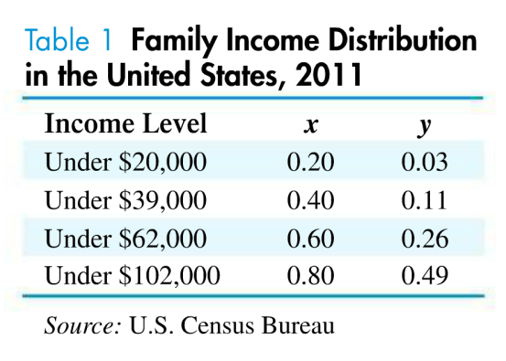 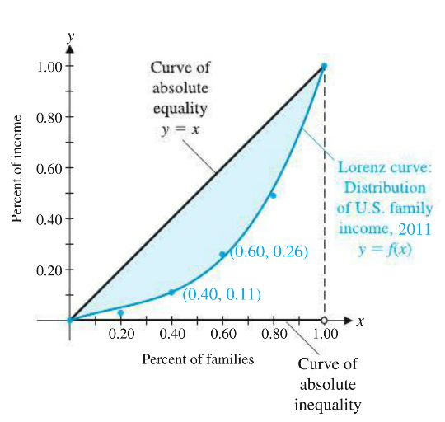

In the example above, the data point  indicates that the bottom 40% of families (those with incomes under $39,000) received 11% of the total income for all families in 2011.

**Gini Index of Concentration**

If  is the equation of a Lorenz curve, then

Gini index .

The Gini index is always a number between 0 and 1 and measures the income concentration. A Gini index of 0 indicates absolute equality of income. A Gini index of 1 indicates absolute inequality of income, that is, one family earned all the income and the rest have none.