Section 4.2 The Second Derivative and Graphs

# Topic 1: Using Concavity as a Graphing Tool

In the last section, we used the derivative to determine when a graph is rising or falling. Now we want to see what the **second derivative** (the derivative of the derivative) can tell us about the shape of a graph.

For  the **second derivative of *f***, provided that it exists, is .

Other notations for the second derivative are  and .

The graph of a function *f* is **concave upward** on the interval  if is increasing on and is **concave downward** on the interval  if  is decreasing on .

For the interval , if then  is increasing and the graph of *f* is **concave upward**. If thenis decreasing and the graph of *f* is **concave downward**.

Be careful not to confuse concavity with rising and falling. A graph that is concave upward on an interval may be falling, rising, or both falling and rising on that interval. A similar statement holds for a graph that is concave downward. See the pictures below.

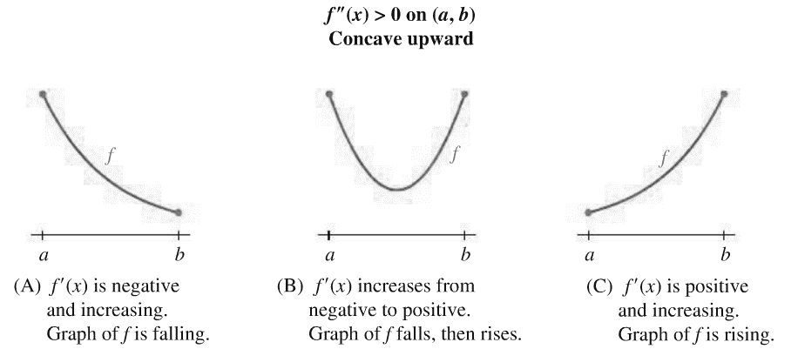

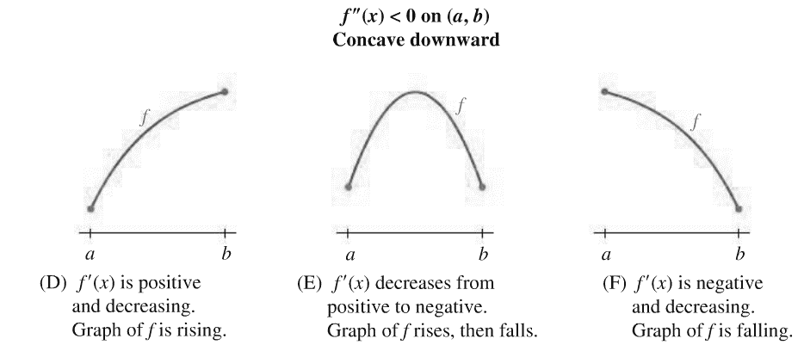

# Topic 2: Finding Inflection Points

An **inflection point** is a point on the graph of a function where the concavity changes (from upward to downward or from downward to upward). For the concavity to change at a point, must change signs at that point.

**Theorem: Inflection Points**

If  is an inflection point of *f*, then *c* is a partition number for .

# Topic 3: Analyzing graphs

# Topic 4: Curve Sketching

**Curve Sketching Strategy**

1. Analyze *f.* Find the domain and the intercepts. The *x*-intercepts are the solutions of , and the *y*-intercept is .
2. Analyze . Find the partition numbers for  and the critical numbers of *f*. Construct a sign chart for . Determine the intervals on which *f* is increasing and decreasing and find the local maxima and minima of *f.*
3. Analyze . Find the partition numbers for . Construct a sign chart for . Determine the intervals on which *f* is concave upward and concave downward and find the inflection points of *f.*
4. Sketch the graph of the function *f*. Plot intercepts, local maxima and minima, and inflection points. Plot additional points as needed and complete the sketch.

# Topic 5: Point of Diminishing Returns

If a company decided to increase spending on advertising, it would expect sales to increase. At first, sales would increase at an increasing rate and then increase at a decreasing rate. The dollar amount $x$ at which the rate of change of sales goes from increasing to decreasing is called the **point of diminishing returns**. This is the amount at which the rate of change has a maximum value. Money spent beyond this amount may increase sales but at a lower rate.