Section 3.6 Derivatives as Rates of Change

# Topic 1: Position and Velocity

Suppose an object moves along a straight line and its location at time *t* is given by the **position function **. All positions are measured relative to a reference point . The **displacement** of the object between  and  is  where the elapsed time is  units.

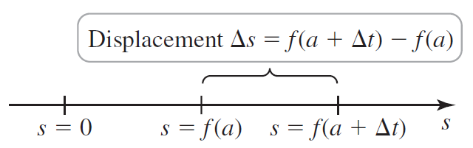

**Average and Instantaneous Velocity**

Let  be the position function of an object moving along a line. The **average velocity** of the object over the time interval  is the slope of the secant line between  and .



The **instantaneous velocity** at *a* is the slope of the line tangent to the position curve at the point , which is the derivative of the position function.



# Topic 2: Speed and Acceleration

When only the magnitude of the velocity is of interest, we use **speed** which is the absolute value of velocity.

A more complete description of an object moving along a line includes its **acceleration** which is the rate of change of the velocity. That is, acceleration is the derivative of the velocity function with respect to time. If the acceleration is positive, the object’s velocity is increasing, and if the acceleration is negative, the object’s velocity is decreasing. Because velocity is the derivative of the position function, acceleration is the second derivative of the position function.

**Velocity, Speed, and Acceleration**

Let  be the position function of an object moving along a line.

* The **velocity** at time *t* is given by .
* The **speed** at time *t* is given by .
* The **acceleration** at time *t* is given by .

# Topic 3: Free Fall

Now, we consider an object moving vertically in Earth’s gravitational field, assuming no other forces (such as air resistance) are at work.

