Section 3.1: The Constant *e* and Continuous Compound Interest

# Topic 1: The Constant e

 or, alternatively, 

The number *e* is irrational and approximately 

The two limits used to define *e* are unlike any we have encountered so far. Some people reason incorrectly that both limits are 1, since  as  and 1 to any power is 1. Consider the following table of values for *s* and  and the graph below for *s* close to 0. Compute the table values with a calculator yourself and try several values of *s* even closer to 0. Note that the function is discontinuous at .

| ***s*** |  |
| --- | --- |
|  |  |
|  |  |
|  |  |
|  |  |
|  |  |
|  |  |
|  |  |
|  |  |
|  |  |
|  |  |
|  |  |

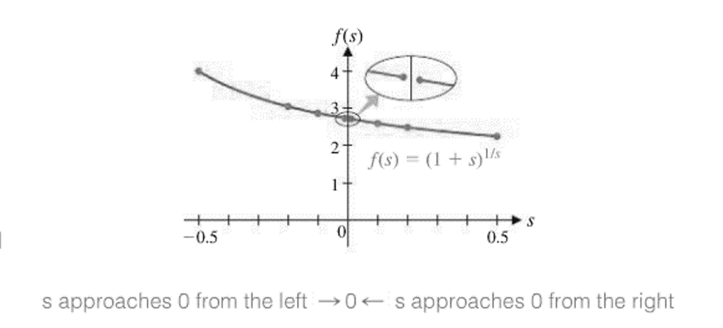

# Topic 2: Continuous Compound Interest

**Recall:** The fee paid to use another’s money is called **interest.** It is usually computed as a percent, called the **interest rate**, of the principal over a given period of time.

The **Compound Interest Formula** is



where *A* is the amount in the account after time *t* in years, *P* is the principal (initial amount in the account), *r* is the annual interest rate as a decimal, and *m* is the number of times interest is compounded per year.

The **Continuous Compound Interest Formula** is



where *A* is the total amount in the account after *t* years, *P* is the principal (initial amount in the account), and *r* is the annual interest rate as a decimal.