**Section 2.4 Infinite Limits**

# Topic 1: Infinite Limits

Suppose *f* is defined for all *x* near *a*. If  grows arbitrarily large for all *x* sufficiently close (but not equal) to *a*, we write .

If  is negative and grows arbitrarily large in magnitude for all *x* sufficiently close (but not equal) to *a*, we write .

**In both cases, the limit does not exist.**

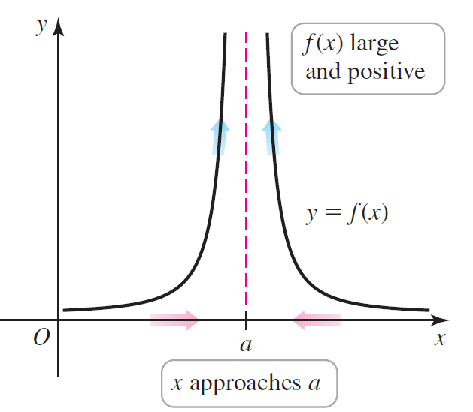 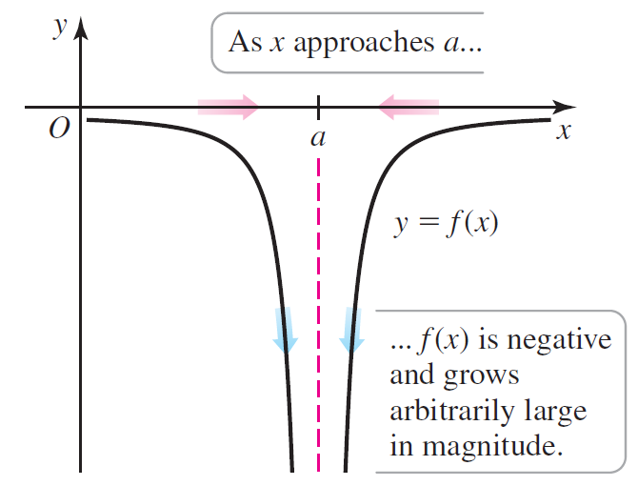

# Topic 2: One-Sided Infinite Limits

Suppose *f* is defined for all *x* near *a* with  . If  grows arbitrarily large for all $x$ sufficiently close to $a$ with , we write .

The one-sided infinite limits, , and  can be defined analogously.

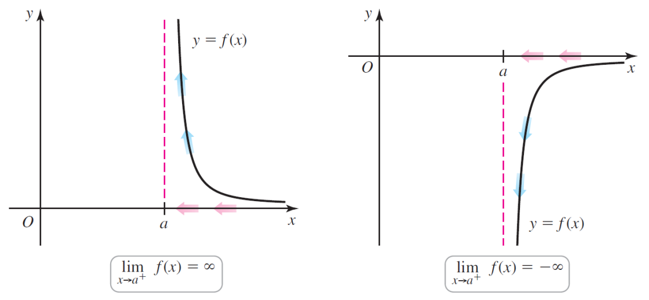

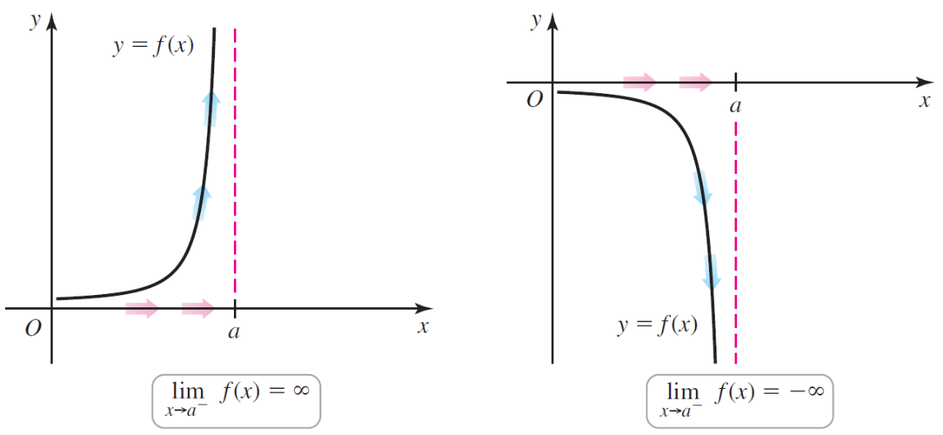

# Topic 3: Finding Infinite Limits Analytically

Many infinite limits are analyzed using a simple arithmetic property:

The fraction  grows arbitrarily large in magnitude if *b* approaches 0 while *a* remains

non-zero and relatively constant.

For example, consider the fraction  for values approaching zero from the right. We see that as  because the numerator approaches 5 while the denominator approaches 0 and is positive. Therefore, .

| ***x*** | 0.01 | 0.001 | 0.0001 |  |
| --- | --- | --- | --- | --- |
|  |  |  |  |  |

This same type of analysis can be used to find .

# Topic 4: Vertical Asymptotes

If , , or , the line  is called a **vertical asymptote** of the graph of *f*.

# Topic 5: Infinite Limits of Trigonometric Functions

A portion of the graph of  is shown below.

