Section 2.2 Definitions of Limits

# Topic 1: Limit of a Function

Suppose the function *f* is defined for all *x* near *a,* except possibly at *a*. If  is arbitrarily

close to *L* for all *x* sufficiently close (but not equal) to *a*, we write .

# Topic 2: Finding Limits from a Graph

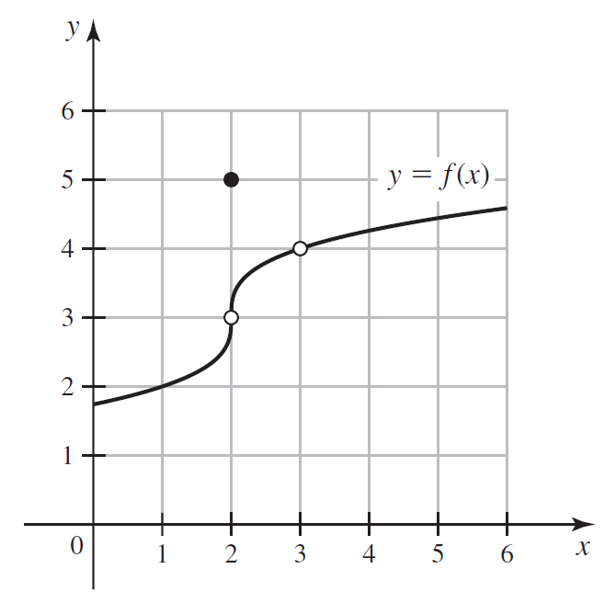

# Topic 3: Finding Limits from a Table

The tables below show values of  for values of *x* approaching 1 from either side.

| *x* | 0.9 | 0.99 | 0.999 |
| --- | --- | --- | --- |
|  | 0.5131670 | 0.5012563 | 0.5001251 |

| *x* | 1.001 | 1.01 | 1.1 |
| --- | --- | --- | --- |
|  | 0.4998751 | 0.4987562 | 0.4880885 |

Make a conjecture about .

# Topic 4: One-Sided Limits

**Right-sided limit:** Suppose *f* is defined for all *x* near *a* with . If  is arbitrarily close to *L* for all *x* sufficiently close to *a* with , we write .

**Left-sided limit:** Suppose *f* is defined for all *x* near *a* with . If is arbitrarily close to *L* for all *x* sufficiently close to *a* with , we write .

**Theorem: Relationship Between One-Sided and Two-Sided Limits**

Assume *f* is defined for all *x* near *a,* except possibly at *a*. Then,  if and only if .