Section 1.5 Exponential Functions

If $a$ and $b$ are positive real numbers, , , and *x* and *y* real numbers, then the following are true:

1. Exponent Laws:











1.  if and only if .
2. For ,  if and only if .

# Topic 1: Exponential Functions

The equation , , , defines an **exponential function** for each different constant *b*, called the **base**. The domain of *f* is the set of all real numbers, and the range of *f* is the set of all positive real numbers.

The graph of  has one of the following two shapes depending on the value of *b*:

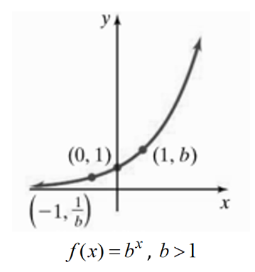 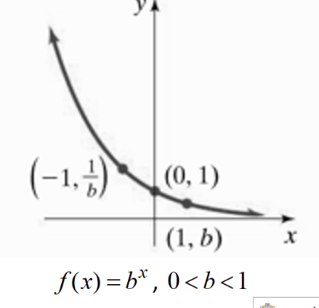

The graph of , , , has the following properties:

1. The graph intersects the *y-*axis at .
2. The graph contains the points  and .
3. The *x*-axis is a horizontal asymptote.
4. If , then  increases as *x* increases, and if , then  decreases as *x* increases.

Recall that the graph of a rational function has at most one horizontal asymptote and that it approaches the horizontal asymptote (if one exists) both as  and . The graph of an exponential function, on the other hand, approaches its horizontal asymptotes as  or as  but not both. In particular, there is no rational function that has the same graph as an exponential function.

# Topic 2: Base e Exponential Functions

**Exponential Functions with base *e* and base ** , respectively, are defined by

 and .

Both functions will have domain  and range .

# Topic 3: Growth and Decay Applications

**Population Growth and Radioactive Decay Models** are defined by  where *y* is the size of the population (or amount present) after time *t*, *c* is the initial population (or initial amount present), and *k* is the rate of growth (or decay)*.*

# Topic 4: Compound Interest

The fee paid to use another’s money is called **interest.** It is usually computed as a percent (called the **interest rate**) of the principal over a given period of time.

**Compound Interest** is defined by the formula



where *A* is the amount in the account after time *t* in years, *P* is the principal (initial amount in the account), *r* is the annual interest rate as a decimal, and *m* is the number of times interest is compounded per year.

**Continuous Compound Interest** is defined by the formula



where *A* is the total amount in the account after *t* years, *P* is the principal (initial amount in the account), and *r* is the annual interest rate as a decimal.